BREEDER OF SHIH TZU’S

SHARES HER SUCCESS FORMULA.
This was written by a very successful Shih Tzu Breeder named Yvonne Cannon. She live in Ireland and is a Summerwinds distributor. This article below is published in the UK Website for Shih Tzu fanciers.
What to Use for the Shih Tzu Coat.
By: Yvonne Cannon
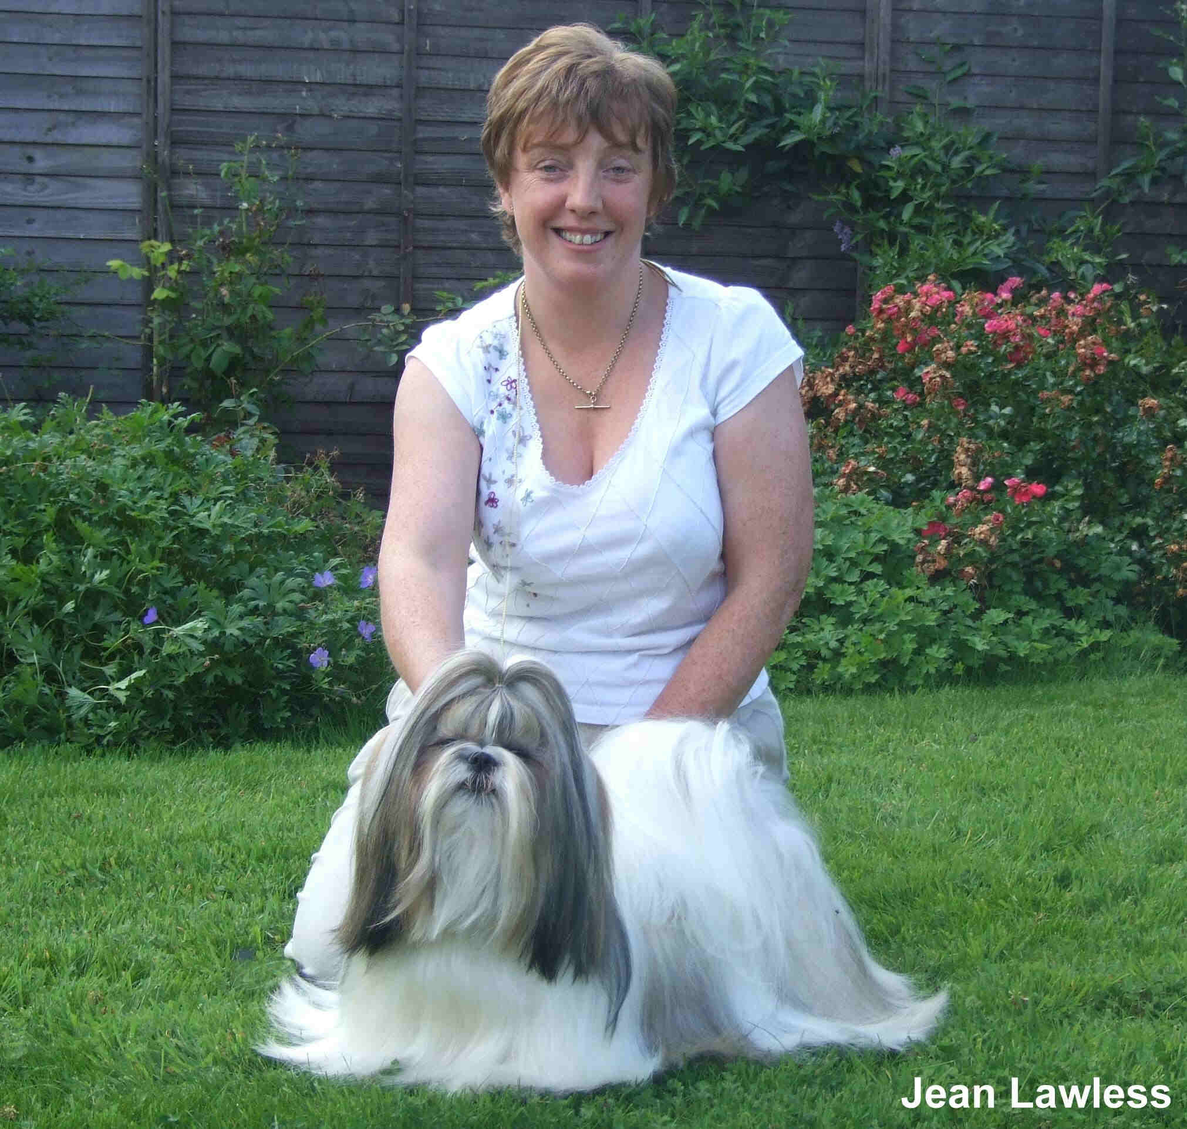
Summerwinds reserves all rights,
No portion of this article may be reproduced
in any media without their express written consent. (Email)

Like humans, every dog’s coat/hair is different, and Shih Tzus are no exception to this. There are the huge coats, some with a coat that is thin, some woolly, some straight, some with a wave. The coat is there from the start, be it good bad or indifferent. You can see a class full of puppies, and some seem to be dripping with coat, some are not, but you may find there is little difference in how these coats have been kept.

There are millions of products available now for sale and rarely do you find a bad product. The product is only as good as the person who is using it and their interpretation of their dogs coat type and texture. Out of desperation a lot of people will grasp at straws and try every product under the sun, expecting immediate results and not giving it a chance and then change to another product. This constant shopping and changing of products, is not good for any coat and can quickly build up residue. The coat should always feel good to the touch, not as if it has a layer of silicone on it or feel almost sticky and brittle.

“KISS” is the key word. Keep It Simple Stupid and that is the basic rules in keeping a Shih Tzus coat, be the dog in full coat or clipped down.

THE SHIH TZU COAT AND WHAT TO USE ON IT.

- 8 – 16 weeks A puppies coat won’t need a tremendous amount of grooming, but the whole process of putting it up on the table or on your lap and brushing should be done nightly or every second night to get the puppy use to being brushed. It need only be for a couple of minutes and It should be a enjoyable experience. The Plush Puppy Porcupine brush which is bristle /nylon mix is suited to this and ideal when you come blow drying your puppy and great for blowing drying the adult dogs coat. You should never ever brush a coat dry and a spray bottle with just water with a little conditioner (such, as Summerwinds Fine-L-Shine) mixed in with or alone Summerwinds Stat-A-Way, which is great as a Grooming Spray. Do not Saturate the coat, but a light misting and brush gently. Plush puppy do three sizes of spray bottles, which give a light misting spray.

- When the puppy gets to about four months and depending on the hair on top of his head whether he needs a top knot or not, all depends on the coat of the individual dog. A comb with rotating teeth is also great at this stage, especially for grooming out the topknot area and the whiskers. Also take note of the bands you are using, the light weight bands are great for a puppy coat, don’t use the heavier bands, like the ones you would use to put up a top knot.

- If your puppy tends to have staining around the eyes Dogs Stuff Kleen Face is wonderful, but again you must use it every day and it’s not a case of hit and miss. If the staining is very bad, put some Kleen Face on cotton wool and wipe from the inner eye down the whiskers. Do this three times a day for 10 days and then once a day thereafter. DO NOT PUT IT INTO THE EYE.

- Coats all grow at varying rates and nothing really can make it grow any faster, basically a dog is born with a coat or not. The job “YOU” have is to protect and preserve what coat is there. The most important aspect of protecting the coat is shampooing and conditioning and doing this regularly. Brushing in between is fine, but if they coat is generally tangle free, just a daily check up and changing bands is all that is required. If you are trying to keep the coat in show condition, it is not a case of waiting until the coat is dirty to wait and wash the dog. It is a case of monitoring the coat and once it starts to feel grubby or grimy and looks as if it is about to start to have knots in places well that is the time to bath.

- If the coat gets to the stage of knotting or tangling then you spend hours trying to brush the tangles out, and you lose more coat this way.

- There are plenty of Shampoos and Conditioners on the market, which one to use is the big question. Some people, find products that works on all their dogs coats and they stick to it, some keep shopping and changing and looking for that magical product that will grow, protect and groom the dog all in one!!!! How we would all love that.

- Firstly, any of the products mentioned are suitable for all Shih Tzu be they clipped down or in Full coat. Obviously clipped down dogs won’t require the same high level of maintenance as a dog in full coat.

- Secondly, if you are going to show your dog no product maybe left in the coat or be found in the coat. It is a KC ruling. Nothing other than water maybe be found if your dog is tested.

- Thirdly, THE PRODUCTS!!!!

- Remember with the regular blow drying that the show dogs get the coat needs to be constantly fed (what is meant by that is conditioned). Unless the dog is terribly, terribly dirty, only wash the dog once and this would apply with any shampoo being used. Remember, a lot of the shampoos on the market are concentrates, so dilute down according to the manufacturers recommendations. Summerwinds do a Shampoo called Summerwinds Shine-Onnn which is very gentle, and with the proper pH 6.5 balance for dogs and can be used full strength on areas that maybe slightly stained or diluted down for general washing. It is easily rinsed out and is in no way harsh on the coat.

- The most important part of the washing process is the use of Conditioners. Make up a litre bottle of conditioner (read label for recommended dilutions) and the Summerwinds Fine-L-Shine seem very suited to the Shih Tzu coats.

- Be generous with the conditioner, it is one of the most important elements of the grooming process. Being lean and cost effective on conditioner, may lead you to spending a lot of money on product to try and help repair what damage may occur to no conditioning. Leave it in for a couple of minutes and then shower off. Remember if you are washing for Show days, do not condition top knot area as it makes it soft and harder to get the topknot put up right.

- After rinsing out the conditioner from your dogs coat. Take out the excess water and wrap your dog in a towel and place in a cage or on a chair or bed in a warm place. No draughts. Do not dry the dog immediately, wait about twenty minutes and then start working on the coat. What you need is a pin brush, again Plush Puppy do a good pin brush, the Plush Puppy porcupine brush, and the untangler comb with rotating teeth. When blow drying work with the coat, not against it. It’s like sanding a table down, don’t go against the grain. With the dryer over the area you are drying work with your pin brush or porcupine brush, and also if you come across a knot work it out with your fingers. Take your index fingers and thumbs and pull gentle apart and then using the brush and keep working like this until the knots are apart.

- When your dog is totally dry, go through the coat, layer by layer with a comb with rotating teeth and check thoroughly that there are no little knots or pin heads.

- Should your dog’s coat start to change and it is endless days of knots and tangles and loss of coat, the following product’s are a wonderful asset. But again each coat is different and constant monitoring of the coat is required. Summerwinds do a Product called Summerwinds Protect-A-Coat, which is a conditioner and oil all mixed into one. The Beauty of this product is that it is easily diluted and also easily washed out of the coat. You should not use this on a dry coat that has any tangles or knots in it. The coat must be Tangle Free. It is recommended that you mix the Summerwinds Protect-A-Coat with the

- Summerwinds Fine-L-Shine, but some people prefer to use the Protect A Coat alone and it all depends on the individual coat. Mix the 2 tablespoons of Summerwinds Protect-A-Coat with a Tablespoon of Fine L Shine and mix in a litre bottle of Water. These measurements are only as a starting point as you may find it is not a strong enough concentration for the coat and you may need to add an additional tablespoon or reduce a tablespoon. If the dog has been bathed in the last day or so and is tangle free just wet the dog thoroughly and then pour on the mixture of Summerwinds Protect-A-Coat and Summerwinds Fine-L-Shine. Ideally wash the dog, condition it and blow dry and then immediately after wet the coat use the Summerwinds Protect A Coat. Make sure you have covered every area of the dog and then wrap the dog in a towel and leave for about twenty minutes to allow it to soak in. (This product is particularly good for dry coats). Then on a low heat, gently dry the dog using the pin brush and comb with rotating teeth. At first you may think areas of the dog are not drying but this is more than likely the oil on the coat. Once the dog is totally dry, band up as normal. You will find that the bands the following morning will break easily; this is due to

- them absorbing the oil, which the coat is doing also. Check the coat daily and make sure there is no clumping together of hairs. If this occurs, just get your spray bottle and spray the offending clumped area and separate and comb through. Monitor the coat to see how it is going and if looks as if it is going to start tangling again, wash the coat in Summerwinds Shine-Onnn Shampoo and do the whole process again. It is good that after two sessions of using Summerwinds Protect-A-Coat that you wash your dog and use normal conditioner and give the coat time out from the Summerwinds Protect-A-Coat and also give you a chance to see how it is progressing. This is all trial and error in what dilutions you can use, all coats are different so some you may need to use more Summerwinds Protect-A-Coat, other less. Remember dedication is required for all of the above.

EMERGENCIES
- We have all had emergencies, where a dog has soiled his coat or gets dirty. Some products to have to hand in your box, although rarely used, absolutely invaluable when the accident occurs. Plush Puppy Powder Puff Regular. This is great for soiled areas and once you have cleaned it up, put the Powder Puff in the Coat and leave in for a while and then brush out. It masks the offending smell and cleans at the same time. Also Plush Puppy and Pet Silk both do a No Rinse Shampoo.

TO HELP GET ALL THINGS WHITE
- Staining can be a problem especially if your dog lives a normal life running the garden (which it should do). These products help, Summerwinds Shine-Onnn Shampoo, which can be used neat on stained areas,

- There is no EXCUSE in this day and Age and the products available to in anyway inhibit the freedom of any dog, there are those that constantly confine

- dogs in puppy pens/rack pens in order to keep a coat!!!!! A Dog should be allowed to run and explore the garden and go for walks. One you are dedicated to the coat it should look good and let the sacrifices for a good coat be your time, not your dogs confinement.

Yvonne R. Cannon
Classic Coat Care

