The art of presenting a competitive show dog

By Rosemary Sutton

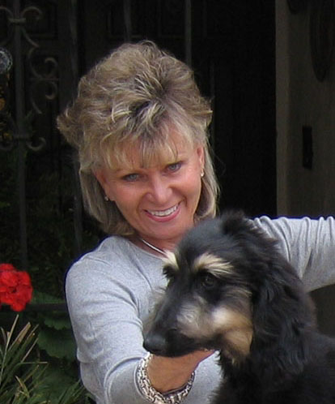

Summerwinds reserves all rights,
no portion of this article may be reproduced
in any media without their express written consent. (Email)
INTRODUCTION: To the dog show world.
I have enjoyed and profited from the dog show industry in many ways both emotionally and financially.
Emotionally: Through all of my wonderful experiences, accomplishments, and good friendships together with a lot of fun times. Finding a passion I love that has fulfilled many of my dreams. It’s allowed me to be able to enjoy my dogs in work and play.
Financially: Through the success of our Summerwinds Business that has supported us for 27 years. Plus, the handling of many dogs in different breeds professionally.
If you are taking the time to read this, I would presume that you have a dog maybe and Afghan or another long coated breed; or perhaps a curly or harsh wiry and even a short coated breed for that mater. Maybe your dog is a pet or a rescue that you and your family just love and don’t show but enjoy seeing him in a beautiful coat and want to do the very best by him/her. Your dog might be a show dog that you think would be fun to show occasionally to try and make him/her a champion and are interested in learning how to train and groom him for the shows. At this stage, you would be called the hobbyist. You might find out that you will enjoy showing your dogs so much you have (as we say), been bitten by the dog show bug. If your dog is competitive and begins to win a lot, you may even experience an ado fin rush that sometime accompanies a big win. Now I’m warning you; if this does happen to you, hang on tight because this is when the dog show sport or game, according to the terminology, becomes a whole new adventure. The sport of showing dogs is in itself is a sumpculture. We have our own rules, laws, language and terminology. You will quickly find that one dog isn’t enough. Your house and car isn’t big enough, and don’t be surprised if you end up moving out in the country where you can have kennel faculties. According to how ambitious you become, your life is in for a big change. I call it “after I went to the dogs”.
In my experience, the people we refer to as high profile people, those that win a lot and most people know of them, have many of the same things in common. They are very ambitious, committed, intense, driven constant, passionate, not to mentioned obsessed and not at all afraid of a little hard work. Of course, this would also apply to any high profile person in any field. No matter how ambitious you are or aren’t, there is a place for you and your dog at the dog shows.
One of the blessings at this point in my life is to be able to share some of my experiences and knowledge gained over the many years of participating in the dog show industry. I have been called both an expert and an authority (among other things…oops). I am not sure if this is a fact, but what I have learned is that an expert is someone that lives a long ways away from you. So, what I am about to share are methods that I have found that work for me.
I purchased my first Afghan hound in 1968. Over many years of trial and error, I have found short cuts that gave me the same results as other methods that were very time consuming. Choosing the Afghan Hound breed alone is a very labor intense breed. If you too have chosen Afghans as your breed, let me warn you right now, you can find some short cuts, but truthfully, you are in for a ton of work and grooming. So you might as well get use to it. The acronym KISS (keep it simple stupid) means learn simple steps how to do it right, and it doesn’t matter whom you learn it from as long as it works for you. Many years ago, I had a friend that use to say, “check the record” that would be the best advise I could give you. I took a little from this person and a little from another.
One of my favorite saying is, “when you’re green you’re growing, when you’re ripe you rot!” I try and learn something new every day; as you are never too old or experienced to learn. What I love the most about a really sincere novice is their ambition, they are like mental sponges and so eager for information and want to learn all they can about how to groom and do it right and what products will give them the best results.
Anyone who knows me knows me well enough to not ask me a question if you don’t want an in-depth answer. To say that detail and full explanations is my forte would be an understatement. Some people are very good at Reader Digest responses; there are others that like the “Gone With The Wind” type answer. For some of you who like to cut to the chase, I have made this article and its contents with subjects titles so you are able to skip over what you aren’t interested in and still go away with a little more understanding and knowledge than before you took the time to try and read this. The rest is for those who always have a million more questions after I think I answered all of them. I have gone into more depth and detail for those with inquiring minds that “really want to know”. I find that one of the hardest subjects to teach people are the subjects that they aren’t inquisitive about; from the basics to the extravagant. Yet, they want to know how to complete a task and be good at it before they truly understand the whole structure of the project. If you understand the total basics of why something is like it is and how to keep it protected and remain in good condition, the easier it will be for you to accomplish your goal. My effort here is to try and share with you how to be a winner and give you the ability to exhibit and put down a dog in pristine coat condition, and well trained and behaved to make showing dogs a rewarding and pleasant experience for you and your dog.
Training, grooming and discipline and all things pertaining to cultivating and caring for a dog, and the proper method of achieving the best results is according to who you talk to and the different breeds you are talking about.
When discussing grooming and grooming products for example, in every breed you will find as many different opinions as you will find breeders, owners, handlers and groomers on how to achieve the best and easiest methods and products to cleanse, condition coat and skin, protect and de-mat coats to produce a competitive show coat in their breed. Let alone when we talk about so many different breeds and textures of coats from very fine, straight or curly to harsh and wiry to short and smooth with each breed standards describing what is the proper coat type for that breed. Your goal is achieve your breed’s desired coat in the best way you can. What to believe and whose advise to follow can be a very puzzling dilemma for a novice. My advice here is to find someone you admire that has achieved what you want in your breed or just in general. You will be given a lot of advice, both free and sought after. A great place to start is from your breeder and if he/she is a good mentor. Free advice, perhaps from a novice or a long-time breeder/owner or professional handler of who each might have a different way to groom, condition and protect coat. You job is going to be to weed through all the advice and find out what’s really truth or fiction. The fact is that I know many long-time breeders/owners that never really get how to put down a completive show coat. This can be the difference in your dog being a winner or a filer. A filer is a dog that attends each show event that never wins, but fills the class to make points for the dogs that do win. Your goal is for your dog not to become a filer due to your lack of knowledge and to be able to put down a dog in completive condition. Just because a dog has a long coat, doesn’t mean the coat is in good healthy condition. It might be dull and faded. There are many ways to skin a cat so to speak. No one-way is the best way and nothing is written in stone. Whatever it takes to achieve the results you will need to win is what you need to learn. And your goal should be to make you and your dog stand out from the others.
For the inquiring minds:
NUTRITION FOR THE CANINE:
The way to achieve the best results for a beautiful coat on your Afghan hound or any long, short, curly, or harsh coarse coated breed is to have your dog first healthy, clean and well conditioned. Many people will ask me “how do I get a gorgeous coat on my dog?”. I tell them, it starts with a healthy dog. A sick, malnutrition or diseased dog cannot produce a gorgeous coat. You must start from the inside and then work out. A healthy dog, if genetically factored correctly, will produce a wonderful strong, shiny, and lustrous coat. It all starts by what kind of nutrition is fed to your dog. A healthy diet for the canine is to remember the canine is a carnivore (a flesh eating mammal) a hunter by nature. If he were hunting game (which he was intended to do) for food, he would kill the game and eat its stomach first for the pre-digested enzymes and the green that the game had eaten. That is where the dog gets his greens type vegetables. He would not eat carrots, peas, broccoli, rice (brown or white), wheat or corn. Then he would eat the flesh meat of the game for the protein, eight essential amino acids, many vitamins and minerals, such as vitamins B₂ and B₁₂, vitamin D, iron, zinc and fibre for the energy to hunt tomorrow. Meat is a natural food, free of damaging man-made hydrogenated fats and oils. He would eat the Internal organs, such as heart, liver, kidneys, etc.; loaded with vital nutrients. He would also eat some bones for calcium, phosphorus and the marrow (medullar cavity) inside middle of some of the bones filled with many attributes. Not all bone contain Medullar cavity. It is found in the long bones (i.e., femur or thigh bone.) Bone Marrow contains Melanoma-reactive CD₈+ effectors T-cells, and Memory T-Cells and blood cells; not to mention calcium, phosphorus and trace mineral, I recommend that a full grown Afghan be fed about 1/3-lb of meat per day. I know that many feel that an all raw meat diet is best, but it can be difficult to do with people’s busy lives, and it can be very time consuming along with the freezer space to keep the raw meat. Total raw meat diets are very hard to balance for dogs to insure the proper proteins, grains, vitamins and mineral intake. The same as it is for a human to eat a total vegetarian diet. I feed dry dog food (about one cup per day) for the grains and fibre mainly with 1/3-lb of fresh raw meats. Dogs can digest raw meats with no problems. They don't have the ability to cook their meats in the wild. . When you cook meat, you kill the natural enzymes and destroy many vitamins, (i.e., beef, chicken, lamb, venison, etc.; not turkey it can be a little too rich.) I also add Summerwinds Health-E-Coat food vitamin supplement focusing on nutrients that help feed hair. Summerwinds Health-E-Coat Supplement is pure food and all natural. Along with E3 Live AFA blue/green algae and E3 Live Enzymes to help digestion and the body to absorb the nutrients it consumed. I feed this to each of my dogs every day. I do know that many people worry about feeding all natural dry dog foods and what all is in the kibble; how much protein is in each and if it has salts, taurine, eggs, or gluten, etc., etc., On and on…. I myself really don’t worry that much about the kibble contents. I do want the kibble to be safe, of course, because I am not feeding just kibble and relying on the dry dog food to supply all the nutrients my dogs will need. I have been to the manufacturing plants that dog food kibble are produced in. They mix all ingredients in huge mixers as big as a large truck. Yes, they add a bag of vitamins A, B’s, C, E, minerals, etc., and the vitamins and mineral that they state on the package, but who's to say that it is so well mixed and distributed that each bag contains exactly what it says on the label. I do not rely on all my dog’s nutrients coming from the kibble. I prefer that the protein not higher than the 20%, if I can get it, because I am adding fresh meat to my dog’s diet that's full of natural protein. I would also prefer that the kibble contain no hydrogenated fats and oils because when oils set for long periods of time (as they do in any bag of dry dog food) they become rancid and destroys vitamin B's. The oils in the fresh meat I am giving, along with what is in Summerwinds Health-E-Coat Supplement, provides all the oil necessary that are natural with no hydrogenated fats That is why I add meat and our Summerwinds Heath-E-Coat Supplement along with E3 Live AFA & Enzymes. This has worked for me for many years now. My dogs are extremely healthy, full of energy, have longevity, are happy and grow gorgeous coats.

Hair and Nails are appendages of the skin; they are the last part of the body to be sent nutrients. Blood is what feeds hair and nails. The body first uses the nutrients to take care of the vital organs, extremities, tissues, and lastly the hair and nails are fed. So if the animal is deficient at all in any nutrients, the hair and nail will be the first to suffer.
SKIN PROBLEMS AND DISORDERS:
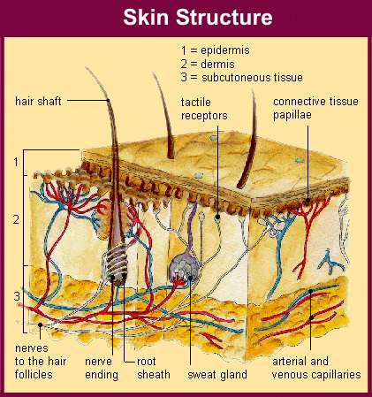
Whether you are trying to cultivate a show coat or just keep a pet in healthy condition, the internal system of the skin is the one of the most important tissue to maintain. It is the largest organ in the body. If your animal suffers from skin disorders not only will he be uncomfortable and sometimes even in pain, there is no way on earth you will be able to put a gorgeous show coat on your animal until you find the source and cure. So if your animals start to show signs of any skin problems, deal with it immediately! Do not procrastinate; these problems don’t usually cure themselves. Summerwinds has two products that can aid in the relief of itching. Summerwinds Stop-N-Itch Bath and Summerwinds Stop-N-Itch Lotion. Dry and itchy skin can come from many reasons, as I am sure you are aware of.
- Allergies from foods, or things in their environment
- Topical Products (i.e.) shampoo's conditions, styling agents, etc.
- Cold and dry weather or hot and humid change in seasons.
- Fleas or Ticks
- Stress can cause mites to activate causing Mange or Cytological Problems
- Disease or Yeast Infection
Below are a couple websites that will explain it more scientifically.
http://www.thepetcenter.com/gen/itch.html
http://www.k9web.com/dog-faqs/medical/canine-allergies.html

ANATOMY OF HAIR
The hair can be divided into two parts, the root and shaft. The root part of hair is in the skin (epidermis) of scalp. A pouch like structure called follicle surrounds the hair root. The base of hair root is in the shape of a bulb. Capillaries and nerve fibers indent this bulb. The cells in the center of bulb divide. The newly divided hair cells push the previous cells up. The cells, which move upwards, die slowly forming hard hair shaft.  Hair is composed primarily of proteins (88%). These proteins are of a hard fibrous type known as keratin.  The hair shaft has three layers the cuticle, medulla and cortex.  Cuticle is the outer layers and protects the inner layers. It is transparent. Healthy cuticle gives a shiny appearance for hair and unhealthy cuticle gives lifeless look  Medulla is the innermost layer composed of large cells.  Cortex is the layer between cuticle and medulla. This contains pigment and keratin. Cortex determines the bulk and strength of hair.  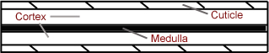 | 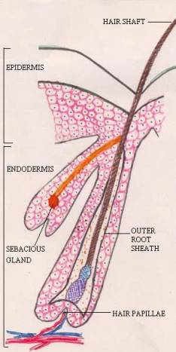
The hair follicle contains oil-secreting glands, which make the hair shiny. Stress and illness and lack of proper nutrients diminish secretion of oil and pigments causing graying of hair.
The hair is considered as a tissue which uses the same nutrients of bone, nails and which is formed as bi-product of bone tissue.
Normal hair growth cycle:
Each hair grows approximately at the rate of 1 centimeter per month. This growth continues for 2-6 years. When the hair attains full growth it resets for 2-3 months and is later shed.
A new hair starts growing in its place. Thus at any given point of time 10 percent of the total hair on our scalp is in a resting phase and 90 percent of the hair is in growth phase.
As apart of this hair growth cycle it is normal for every warm blooded animal to experience a little hair fall every day. Any condition in which the hair fall is more than normal is termed as hair loss. Hair loss can affect anybody irrespective of age and gender.
Hair and different textures
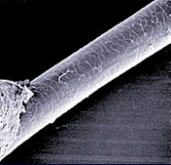
Fine hair is close to the resolution of the human eye, about as fine as we can see. Hair thickness varies from person to person, animal to animal, day to day, year to year.
It’s anywhere between 1/1500 to 1/450 inches (17 to 181 microns). Hair color is the biggest factor. Flaxen hair is the finest (1/1500 to 1/500 inches, 17 to 51 microns) and black hair the coarsest (1/450 to 1/140 inches, 56 to 181 microns).
Warming weather can thicken hair
Hair shape (round or oval cross-section) and texture (curly or straight) is influenced heavily by genes. However, nutritional status and intentional alteration (heat curling, "perms") can affect the physical appearance of hair.

Hair Pigment
Hair color is mostly the result of pigments -- chemical compounds that reflect certain wavelengths of visible light. There is two main pigments found in human hair: Eumelanin has an oval or elliptical shape, which gives color to brown or black hair and is dark pigment. The higher the concentration of Eumelanin the darker the hair.
Pheomelanin is what produces the color in blonde or red hair. The higher the concentration of phaeomelanin, the lighter the hair. Unlike eumelanin, phaeomelanin is smaller, partly oval and has a rod shape. White hair contains no melanin at all and gray hair contains only a few melanin granules.
Although some scientists believe that the derivation of pigment is probably derived from colo-forming sumpstances in the blood. The color of the hair, light or dark, depends upon the color and amount of the grains of pigment it contains.
Natural hair color may also be influenced by the optical effects of light rays by melanin, either as they are absorbed or reflected and bouncing off the surfaces of the different hair layers. The size, amount and distribution of melanin determine the ultimate hair color. Great number of large melanin Molecules distributed throughout the cortex to create different colors. The various combinations in the size, amount and distribution of melanin create all natural hair color. Which contributes to the many different types of texture in hair and coats.
What is the difference between fur and hair?
The term "fur" refers to the body hair of non-human mammals also known as the pelage (like the term, plumage in birds). The main difference between hair and fur is where it grows, not what it’s made of. Human’s, have long hair on their heads and short hair on their arms, while a deer has short hair all over. Also, unlike hair, fur includes a layer of finer, shorter denser hairs, the under fur, through which longer, coarser, more thinly distributed guard hairs extend.
So fur is hair, but it is used to describe the dense uniform hair covering on animals.
THE DIFFERENT TYPE OF COATS IN DOGS:
There are over 400 breeds of dogs. Between them, there are literally dozens of coat types.
Coat Length
Long, medium and short. For example, both Old English sheep dogs and Afghans have long coats; however, the two breeds could not have grooming requirements that are more different. Even short-coated breeds can have different grooming requirements. The Labrador retriever and Miniature Pinscher are both shorthaired, but the first has a dense and oily coat, while the second coat is hard and close lying to the skin. Some dogs have coats between these two extremes. The Papillon, with its wavy coat and attractive frills on its ears, tail, and ruff, has a medium-length coat.
Hair Type
There are three types of hair types: straight, wire, and curly. Straight coats are perhaps the most familiar. The short-coated Whippet and the long-coated Rough Collie both have straight outer "guard hair" for their coats. Most of the Terrier’s breeds have "wire" coats. The outer guard hairs that are straight in other breeds are harsh and kinked. Some sporting breeds to retrieve game from the water have curly oily coats. They can be soft or harsh, depending on the breed.
Coat Density
Coats are either single or double in density. Double coats consist of outer guard hairs, with an inner layer of shorter, finer coat called undercoat. This undercoat can be fine or downy, thick or thin. Dogs with single coats have the outer guard hairs, but lack the inner layer of undercoat. Most breeds with single coats also have long hair. Many single-coated dogs, like the Maltese, were developed to be decorative, rather than functional. Dogs from warm climates, like the Afghan hound also have single coats.
Grooming for Coat Type
Different coat types will have different grooming requirements briefly described below.
Short Coats: short straight coats are of course the easiest to care for, requiring occasional grooming with a slicker brush or a soft brush. However, those short-coated breeds with a dense undercoat will also require that undercoat t be groomed out on occasion. Using a brush known as a shedding rake like Untangle Shedding Rake to rid the dog from dead hair in the undercoat will prevent mats from forming. If mats form underneath the guard hairs and remain for any length of time, sores and hair loss, known as "hot spots" can occur. Some dogs, such as Alaskan Malamutes and German Shepherds, have such thick undercoats that they require frequent, if not daily, grooming to prevent these mats from forming in sensitive areas. Removing this dead undercoat will also cut down on the dog shedding his coat all over your house.
Wire Coats: wire-coated dogs have unique grooming needs. Each different breed of Terriers will have a little different trim on the head and body, but most will have a process called “stripping" which is done by hand or the aid of a stripping knife a couple times a year. Dead guard hairs are plucked for the dog’s coat. Their hairs are loose and about to drop out so removing them does not cause the dog pain. This allows fresh new coat to grow in, along with preventing a lot of excess shedding.
Long Coats; long coats require a lot of attention. Their coats must be groomed several times a week, if not daily, to ensure that they remain free of tangles and mats. Bathing once a week and thoroughly brushing and combing through the dogs coat will help to keep the mating under control. Long coated dogs with double coats require the same attention as double-coated shorthaired dogs.
Single-coated long coated dogs have special grooming needs. Dogs with these kinds of coats, such as Afghan hounds and Maltese, should never be groomed when their coats are dry. Spray the coat first with water or conditioner such as Summerwinds Fine L Shine Cream Rinse or Summerwinds Stat-A-Way Spray before brushing or combing to prevent the coat from breakage. Mating in Single-coated breeds is a big problem and in order to keep the coats mat free they must be monitored frequently to prevent this from happening.
Unique Coats
Corded Coats; are breeds that have curly hair and are allowed to mat forming “cords”, similar to dreadlocks. The "cords" that form this kind of coat are specialized mats. They create a weather-resistant shield in herding and some hunting breeds. Dogs with corded coats require baths to keep their coats clean and order free. Corded coats take hours to dry following each bath.
Hairless Breeds; have no coats. The American Hairless terrier and the Chinese Crested dogs are examples of hairless dogs. Their skin must be maintained, just as other dogs' coats are groomed. They need regular baths and moisturizer and sunscreen must be applied for their skin.
GENERAL PRODUCT FACTS:
Natural or Organic:
In hair care products there are no such thing as all natural products. Ingredients derived from natural sources lose their natural composition when they are processed to make cosmetic products. Cleaning ingredient in shampoos and conditioning agents in conditioners are just a few. They may start from plant derivatives, but are altered drastically to be a shampoo or conditioner. Adding natural or organic products to the shampoo or conditioner are done for performance enhancement.
SHAMPOO:
The purpose of a shampoo is to clean the hair. It is important that shampoo does not clean too well, or all of the protective oils in the hair would be stripped out.
Detergents:
The most common ingredient in shampoos is detergent, which is used in other products, a class of surfactants known as straight-chain alkyl benzene sulfonates. An example is Ammonium Lauryl Sulfate, or its sodium relative, or the slightly larger related molecule ammonium lauryl ether sulfate, sometimes abbreviated as ammonium laureth sulfate.
These detergents work best in water that has little calcium and magnesium, as these elements bind to the detergent and make an insoluble scum. So tetrasodium EDTA is used to sequester the calcium and magnesium from the detergent, while keeping them soluble so they rinse away without scum.
Cocamide DEA (or MEA or TEA) is used as a foaming agent to make the lather. The other surfactants will generate a certain amount of suds, but this foaming agent is added to get the amount just right. Besides its foam stabilizing effects, it is also a viscosity booster (it's thick).
The detergent cocamidopropyl betaine is added for several of its special properties. It is milder on the skin than the benzene suffocates, so adding it to the mix reduces the amount of the harsher detergents needed. It is thicker than the other ingredients, so it can be added to make the mix have the right viscosity. It has anti-static properties so the hair doesn't generate an electric charge and jump to the plastic combs and brushes used when drying the hair. It is a humectant, attracting moisture from the air, thus keeping hair from drying out. Lastly, it has antibiotic properties that can prevent spoiling of the shampoo.

Special effects:
Sodium chloride (table salt) is used to thicken the mixture if the main surfactants are sodium lauryl sulfates. If the surfactants are ammonium based, then ammonium chloride is used. Salt can make the shampoo harsh, drying, sting the eyes, and irritating to the skin leaving it itchy. In Summerwinds Shine-Onnn, Summerwinds Take-A-Hike and Summerwinds Stop-N-Itch Bath there is no Sodium Chloride added.
Glycerin is added as a humectants (draws moisture from the air), as is propylene glycol, which is also a preservative.
All Summerwinds shampoo’s have Amino acids added that act as conditioners.
Preservatives
Two widely used preservatives, DMDM hydantoin and imidasolidinyl urea are found in many shampoos, to prevent fungal and bacterial spoilage. They release formaldehyde to kill germs.
Sodium benzoate and 2-bromo-2nitropropane-1, 3-diol are other preservative’s used in shampoos. It kills bacteria, fungi, and yeasts, and works well in acidic mixtures.
PH balance
The surface of a strand of hair is covered with overlapping sheets, somewhat like the scales on a fish, or the shingles on a house. This surface is called the cuticle.
Alkaline solutions raise these scales so they stand up. This makes the hair rougher, makes it look dull, and makes the hair shafts stick together due to the rough texture.
All Summerwinds Shampoos are made slightly acidic to keep the cuticle smooth and lying flat on the hair shaft.
As shampoo mixes with the water in the bath, or mixes with dirt on the hair, it can become less acidic as the acids mix with alkaline water or dirt. A compound that releases more acidifying ions when the acidity gets low, or absorbs acid when the acidity gets too high, is called a buffer.
A typical buffering agent used in shampoo is sodium citrate. Since the goal is to keep the shampoo slightly acid, the term "pH balanced" is actually a misnomer. The balance should be tipped slightly to the acidic side. Human pH is 5.5. A dog’s pH is 6.5 all of our Summerwinds Shampoo’s are 6.5 pH based. Many pet shampoos on the market are formulated for the human pH of 5.5, with a pet label applied to them.
CLARIFYING SHAMPOO
Clarifying shampoo is any of a variety of shampoo products that are formulated to deep clean the hair by removing product buildup from the hair shafts. Styling products, such as hair spray, conditioners, and even daily shampoos can cause buildup on the hair overtime. This buildup can add weight to the hair, making it flat and lifeless, as well as prevent the reflection of light, which makes the hair appear dull and dingy. Periodic use of a clarifying shampoo will help remove the buildup. Don’t confuse the words buildup with residue. Residue can come from both the conditioning ingredient in shampoos and hair conditioners that will protect the hair shaft. Residue can be a positive and essential end result for the shinny, healthy finished look. Buildup occurs from the accumulation of residue, both from topical styling products as well as some internal medications.
Most clarifying shampoo products contain acetic acid. A chemical compound, though mild as far as acid goes, is known for its de-scaling abilities. As necessary as it is to keep the hair shaft clear of buildup it can be very difficult to find a clarifying shampoo that won't cause more harm than benefit. Many clarifying shampoos are not known for their conditioning abilities. With an improper formulation and harsh stripping agents in the ingredients some clarifying shampoos are great for aiding in the removal of unwanted buildup of oil, styling products, and other grime, but also remove the natural oils in hair and skin leaving the hair dull and dry out.
We at Summerwinds have worked long and hard on formulating our (NEW) Summerwinds Remove-A-Way Clarifying Shampoo. Finally arriving with a perfect answer to how to remove buildup with a mild formula is our Summerwinds Remove-A-Way Clarifying Shampoo. Summerwinds Remove-A-Way Clarifying Shampoo is effective in removing product buildup or any accumulation buildup on the hair shaft. It is formulated not to deep cleanse so thoroughly as to remove any natural oils and moisture in the hair and skin or residue from conditioning agents in shampoos and conditioners that we want to remain on the hair shaft. Along with maintaining the same 6.5 pH balance that is mild and gentle as all the other shampoos in our Summerwinds line.

CONDITIONER
Conditioners are compounds added to keep the hair cuticle smooth and slippery. Silicone oils such as dimethicone and cyclomethicone are used to make the hair shiny and slippery. Humectants (moisturizers) like panthenol help keep the cuticle moist so that the scales do not stand up.
Long chain fatty alcohols like cetyl alcohol, oleyl alcohol and steary alcohol lubricate the hair. One end of the molecule binds to the hair, leaving the slippery fatty end on the outside to rub against other strands of hair, or a comb.
Quaternary ammonium compounds are cationic surfactants that bind well to anionic surfaces like the protein in hair. The ammonium end sticks to the hair, leaving the long fatty end of the molecule to act as a lubricant. They are slightly conductive so they reduce the buildup of static electricity.
The "quats", as they are called, include compounds like stearalkonium chloride, disteardimonium chloride, quaternium-5 or quaternium-18; polyquaternium-10 and they are all similar in form and function to cetrimonium chloride. These compounds help to soften and reduce anti-static. They are also used to thicken the shampoo.
The emollient isopropyl palmitate is used as a skin softener, moisturizer, and as an anti-static agent.
The term " hair conditioner" is vague. Hair conditioners fall into different groups according to what you want to accomplish with the hair. Thin hair need a specific kind of "conditioner", thick, dry hair need another...
Conditioners fall into six major categories:
Moisturizers
Are concentrated with humectants. Humectants are compounds that attract and hold moisture into the hair. They may not necessarily contain botanicals or protein.
Re-constructors
Normally contain protein. Hydrolyzed human hair keratin protein is the best source, because it contains all 19 amino acids found in the hair. Human hair keratin protein has a low molecular weight. This enables it to penetrate the hair shaft (the cortex).
Acidifiers -
The key word here is "acid". Yes, ii is good to put acid on your hair. Hair and skin are acid and don’t like to be in an alkaline condition. When a product carries a pH of 2.5 to 3.5 it is normally termed an acidifier. This pH will close (compact) the cuticle layer of the hair. The result is shiny, bouncy hair. This pH range will adjust the beta bonds to alpha bonds (hydrogen bonds). Acidifiers do not weigh down the hair. They do create shine, and add elasticity. This category is great for fine textured hair.
De-tanglers
Most detangles are acidifiers (see above). Most have low pH's 2.5 to 3.5. They close the cuticle of the hair. Some "shield" the hair shaft with polymers (polymers are strings of "like" molecules- a chain). Some detangles are instant, some take 1-5 minutes to work.
Thermal Protectors
Thermal protectors safeguard the hair shaft against extreme heat. Using thermal protectors are one of the best things you can do to protect hair when blow-drying. They normally use heat-absorbing polymers that distribute the heat, so your hair does not get heat damage (a major cause of hair damage)
Glossers/Polishers
For the most part glossers are cosmetic. Most Glossers contain dimethicone or cyclomethicone (very light oils derived from silicone). Used in small amounts they reflect light. Also, they are one of the best products to control the "frizzles."
Oils (E.F.A.)
When hair is dry (esp. if the hair has been treated with chemicals such as hair color-perm-relaxer} you need to add oil to the hair. The skin and scalp produces natural oil called sebum. E.F.A. are the closest thing to natural sebum (sebum contain E.F.A.). E.F.A. can take very dry and porous hair and transform it into soft pliable hair. E.F.A. acts as a barrier on the skin to help prevent the loss of moisture and thereby moisturize skin. In scientific studies it is one of the most effective occlusive moisturizing ingredients.
Summerwinds Protect A Coat Oil Conditioner is both a Moisturizer, Re-constructors and contains Essential Fatty Acid Oils.
Summerwinds Fine L Shine Cream Rinse Conditioner is both a Moisturizer and Acidifier.

THE BIG OIL DEBATE:
There are many pros and cons about using oils. I am sure that you’ve heard some of them. And in part I couldn’t agree more. There are as many different types of oils as there are opinions. There is heavy petroleum crude oil, animal fat oils, vegetable oils, flower oils, seed oils to light refined oils (EFA) and on and on. All oils are not equal.
For example, LANOLIN is animal fat oil that was very popular buzz/ word in the human hair cosmetic world a while back. LANOLIN is a fatty sumpstance from sheep, by-products of the meat packing industry. But it was quickly learned that it caused more problems than benefits. It is very heavy and is fast to rancid not to mention toxins, including synthetic hormones used to bulk up animals, tend to accumulate in fat tissue. Animal fats tend to clog sebaceous pores more than vegetable oils, not to mention very difficult to remove, by detergents or strong clarifying shampoos.
LANOLIN is a very poor choice, for human care products let alone for animals with very fine coats. If the LANOLIN is left in the coat for longer than 3 to 4 days it begins to dry out, and can cause itching and mating and making more work for yourself.
It doesn’t do you any good to put your dog down in heavy oil that the only way to remove them form the skin and coat on show day’s is to use a detergent. Not only does the detergent remove the LANOLIN or HEAVY WEIGHT OILS, it removes the natural oils and moisture from the animal’s hair and skin.
What we use in Summerwinds Protect A Coat Oil Conditioner is light refined oils (E.F.A.) and E.F.A. (Essential Fatty Acid), that will not only protect the hair shaft but are the closest thing to natural sebum (sebum contains E.F.A.) E.F.A will a take very dry and porous hair and transform it into soft pliable hair. E.F.A. acts as a barrier on the skin to help prevent the loss of moisture and thereby moisturize skin. In scientific studies it is one of the most effective occlusive moisturizing ingredients and is easily removed with one (1) 6.5 pH balance Summerwinds Shine-Onnn Shampoo. Summerwinds Protect A Coat Oil Conditioner is a two (2) in one combo conditioner. The creamy lotion part of Protect A Coat is a moisturizing and re-constructor conditioner, with refined oil (E.F.A.) added.

Shampoo / Conditioner all in one:
Shampoos and Conditioners as you can see from above, do not have the same chemistry and are very different from each other. Shampoos are of alkaline base. Conditioners are acid based. Alkaline and Acid are like oil and water and don’t complement each other. Conditioners are classified as cationic surfactants and Shampoos are classified as anionic surfactants.
Shampoos are designed to cleanse the hair and remove soil and oil build up. They are not meant to adhere to the hair shaft like conditioners. They are meant to cleanse and be rinsed out while conditioners have properties to coat and protect the hair. In other words they will cancel out each other.
The reason for designing the two in one combo is to save time and money by two products in one. Nice idea if it would work, but it doesn’t. It is much better to cleanse and condition individual allowing each product to provide ultimate results and to achieve their full potential.

ANT-STATIC SPRAY
Electrostatic events occur whenever positive and negative electric charges are held apart from each other. When you comb or brush hair on a dry day, you will find that the comb /brush can pick up bits of dust, that is a static electric occurrence, it is an example of static electricity. Maybe reword the above

But there is no electricity in the hair or in the comb. Instead, the rising of the hair is the static electricity. The crackling sounds are the static electricity. Static electricity is most often caused by a lack of moisture in the atmosphere.
This may or may not be of much interest to you, but when you are trying to show a dog who’s hair is suppose to drape and hang down and instead it is sticking out like you struck his toe in a light socket, I am sure that the scientifics of static electricity will get your attention! Next thing will want is to find a product that will control this phenomenon of static electricity. Summerwinds Stat A Way Spray will help combat static in two ways. Summerwinds Stat A Way Spray will put small minute amount oil into the coat, which adds weight, and helps hold in necessary moisture, while deodorizing the coat at the same time. Summerwinds Stat A Way Spray also contains de-tangle properties that protect the hair shaft for ease of grooming and add shine.

CAUTION!!!
Products And Things That Damage Coats The Most…
  - Shampoo is one of the most important selections you will make in choosing the right grooming products. Continue shampooing without restoring the pH balance with a cream rinse acidifier, such as Summerwinds Fine-L-Shine Cream Rinse, will cause the cuticle layer on the shaft of the hair to open resulting in dry, dull, brittle hair and breakage will occur because the chemical makeup of the shampoo itself is made with an alkaline base. I will say it again, hair and skin are acid and do not like to be in an alkaline condition. Especially with harsh shampoos formulated for human’s pH instead of dog’s pH. For this reason, Summerwinds spent countless hours of extensive research development of all of our Summerwinds shampoo formulas.
  - Blow Drying hair with extreme heat, and not protecting the hair first with a thermal protector.
  - Chemically treated hair, such as tinting, perming, and straightening without using reconstructive conditioner.
  - Sun, UV rays without using sunscreen (i.e., Summerwinds Protect A Coat Oil Conditioner with sunscreen.)
  - Chlorine, some dogs will swim daily in swimming pools. Using Summerwinds Protect-A-Coat Oil Conditioner will protect the hair from the harsh chlorine results.
  - Hair sprays, bodifiers, texturizers, moose products that give hair body.
Grooming tools (i.e., brushes that are not used correctly.)

SummerWindS
Helpful hints on Bathing and Grooming the Afghan Hound or Any Long Coated Breed
READY TO START:
AT THIS POINT, I THINK YOU SHOULD BE BETTER ARMED WITH SOME KNOWLEDGE ON NUTRITION FOR THE CANINE AND THE ANATOMY OF SKIN AND HAIR, ALONG WITH PRODUCT INFORMATION, ARE YOU?
Hopefully you have read NUTRITION FOR THE CANINE, ANATOMY OF SKIN AND HAIR and PRODUCT FACTS and have put it into practice. Now, once you have a healthy dog and understand the basics of skin, hair and what products are made of and how they work, you will understand a little more about what it will take to grow a gorgeous coat. “The next question is” now that my dog has a gorgeous coat, how to keep and protect it? It’s one thing to grow a healthy gorgeous coat, but put into the wrong hands and it’s like the old story “some people can make a sows ear out of a silk purse”. An Afghan male will stand as tall as 29 inches. That is a lot of hair growth ahead of you to care for and protect. This coat will be on the dog for years to come if it is cultivated properly. I can’t stress enough, the sooner you start using the right 6.5 pH chemically balanced shampoo products and conditioniers (such as, Summerwinds Shine-Onnn Shampoo, Summerwinds Remove-A-Way Clarifying Shampoo, Summerwinds Fine-L-Shine Cream Rinse Conditioner and Summerwinds Protect-A-Coat Oil Conditioner on the coat of your puppy and learn how to groom correctly, the sooner your dog will have a competitive show coat and you will reap the benefits.
A dog’s coat goes through several different stages that are divided by age and sex. The older the dog gets, the easier the coat care usually becomes to groom. When they are puppies, the coat is short and easy to maintain with little to no mating. This is the time when you should be training your puppy and yourself for easier grooming days and less problems in the future. There are several ways to groom the puppy from lying down on his side or standing on the tablet to be groomed. If you want the dog to lie down, it will usually take some work teaching the pup to lie down and stay still, to get used to having a bath and to accept the hair dryer. Anything new has to be introduced gradually to your puppy, but it’s very important to do it. Don’t wait to train your puppy because the dog is young and really does not need the everyday attention to the coat. By the time the dog is a yearling and begins to mat, it will be much more difficult for you and the dog if he isn’t well trained. Make it easy on you in the beginning, train early and be consistent, with a weekly routine. I cannot stress the importance of this enough. Procrastination has NO place when owning an Afghan Hound show dog, that is if you want to win!

PUPPIES:
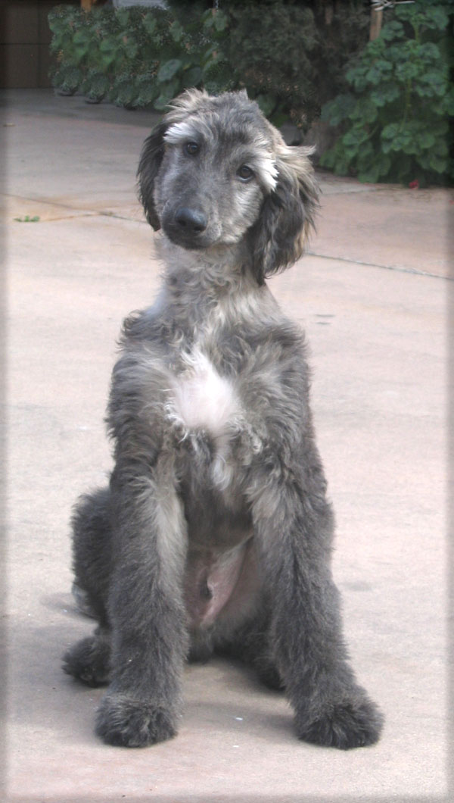
Training your puppy and when should you start.
The training and preparedness of your puppy must begin from the time he is a young puppy. Imprinting is a process that occurs between the third and seventh week of a puppy's life, when the puppy learns to recognize other animals and people and develop relationships with them. This is also when the puppy begins to communicate with us in earnest. It is important to cultivate your puppy’s senses. Experiences should involve the puppy's sense of touch, sight, smell and hearing. It is also good that these experiences are not only to be shared between you and the puppy, but also with other people. Before the puppy has reached a month of life, these socialization activities really have little long-term effects. By the time the puppy is five to six weeks old, these activities should be constant. With the proper socialization process, the puppy should now be bonding with you and other humans.
This is also when the puppy learns his place in the pack and his standing within the hierarchy of it. If you don’t show the puppy that you are the leader of the pack, then this will cause obedience problems later on. After the third month, the puppy's character will begin changing and the socialization process will become more difficult and complicated. If the puppy has not become heavily imprinted towards people then the harm will be irreversible.

Once puppy has received a good imprinting and socialization, he has the basis upon which to build a good line of communication and interaction with you. From the third week of life till the fourth month, the experiences that the puppy has will have a heavy impact on its life-long character and personality. I believe that a puppy that is exposed to a wide range of sensory stimulating experiences during these early weeks has a strong advantage over those that haven't. Showing your dog will require being touched by many different people and use to a lot of experiences, such as load speakers, crowds, people and dogs. The better his social skills the easier it will be for him.

Grooming your puppy and when should you start…
When a puppy is from 8 to 18 weeks old, they can get themselves dirty just playing in the dirt, mud and worse. Make cleaning them as easy as possible. Put the puppy in the tub and rinse him off, and then shampoo him with Summerwinds Shine-Onnn Shampoo. This will familiarize the puppy to the feel of; water and the sound and feel of the spray of water, along with different fragrances. The puppy may not like his first few baths, but eventually he will become use to it. The earlier he is introduced to the bathing and grooming routine, the better. After all, being a dog with long coat means he will have to be bathed more often and all through his life. When the water hits the puppy, he may become frighten and try to jump out of the tub, so having a collar to grab onto is a good idea. Rinse the puppy as well as you can and then put Summerwinds Fine-L-Shine Cream Rinse (diluted) on him and quickly rinse out. Towel dry and make sure to keep him warm and do not let him get chilled. Afterward, praise and love him and calm him down.
Put the puppy on a grooming table and make sure he won’t fall off. Never leave him unattended on a table hooked from his collar to the grooming arm. He could jump or fall off, breaking something or worse, choking to death. If you have him attached to a grooming table with a leash, make sure that the leash is long enough so he will not strangle himself. Start brushing him with a slicker and then a pin brush, and finish off with a long tooth comb so he gets use to the feel of all three grooming tools. Touch the puppy everywhere and lift their feet and feel of their feet and comb between his toes. If you have a male puppy, be sure to regularly feel for testicles to get him use to having them touched.
The first time you use a dryer on your puppy, hold on to him so that if he becomes a little frightened by the sound, he won’t jump or fall off the table. Do not point the dryer directly at the puppy. Turn it on and let him get used to the noise. Make sure that the dryer isn’t too hot for the puppy. Blow-dry the puppy as much as you can and then let the dog air dry or cage dry until the puppy is completely dry. Every time you bath and groom your dog, you should cut his nails, brush his teeth and clean his ears. This all should become part of your dog's weekly grooming routine.
ADOLESCENTS:
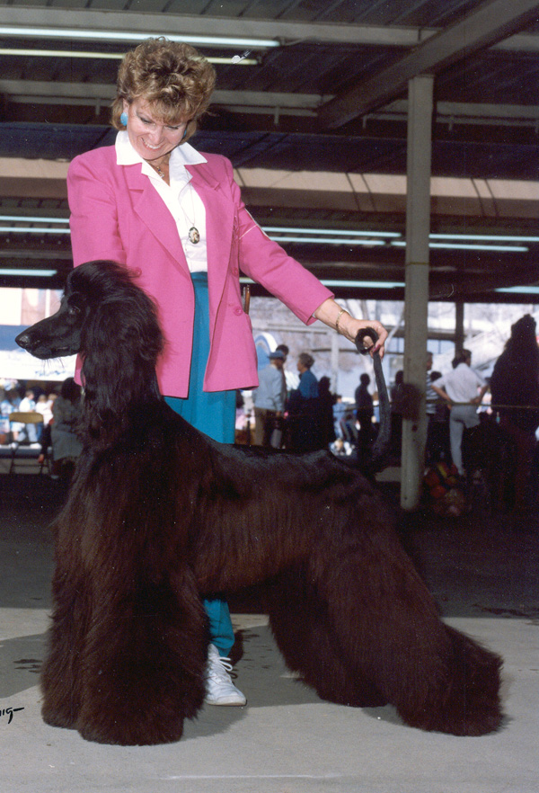
By the time your youngster is an adolescent, he should be behaving well on the table and might even be lying down on his/her side for brushing and combing. For long grooming sections, laying him down can be much easier on him and you. I have an office chair next to my grooming table so that I can sit down along side of the dog as it has wheels and I am still mobile. This method also works out great to clean the tartar off their teeth.
The adolescent’s coat begins to become thicker and longer as the dog ages. Around 9 to18 months, in both bitches and dogs, or your dog is one that is highly patterned or one that might not carry much of a coat, it will start to take longer to dry the dog. As soon as he/she starts shedding his puppy coat, you will find that the coat will start being much harder to manage and is going to mat more then before! We call this period a coat drop. Normally, bitches shed before dogs and as soon as they have come into season, they can have a heavy coat drop. This usually happens about 63 days after their season. Some bitches will even start this coat drop as soon as they come into season. Most will fool you and just when you think they aren’t going to drop their coat, sure enough you can count that about 63 days after their season, a normal bitches coats starts to experience a coat drop. This is due to hormone changes and there isn’t too much you can do about it. Nature will do her thing!
During this coat drop period whether it’s due to hormones or puppy drop, you should put your Afghan on the grooming table and work on and monitor closely the areas that usually mat the most. These areas may include behind the ears; elbows; side coat; middle of their thighs; in front of the hock area on their rear legs, along with the front lower legs and in-between their front legs; and in-between their toes, where ever there is a friction area. All Afghans hate their feet to be touched and especially combed and de-mated, that is a given. It is a good idea to brush and thoroughly comb through the dogs coat several times a week; making sure that huge mats will not occur during this period. Mats will appear to come up overnight and be a tangled, tight mass. This is the period that many novices will lose their dog’s coat. So, I am warning you, don’t skip your grooming day or think you’ll put it off until another day because the mats will not go away and will become out of control and you and the dog will pay a high price for your procrastination. Excuses don’t make winners!!! Each day you put it off will make it harder and harder when you do get to it. If the weather is bad during this period, I would suggest a serious brush and comb through almost every day and baths every 4 to 5 days. It’s tough, but worth it. I, myself, would rather bathe them more often and comb out a few mats than wait too long of a period and spend hours brushing and combing and de-mating the dog. Not to mention the coat you will lose and what you are putting the dog through to de-mat him. It can be very painful for them, and they will begin to hate to be groomed. You will not achieve a beautiful show coat if you can’t keep them from mating. If you don’t do the daily checkups during this period, you will find that de-mating and removing the mats will cause holes behind elbows, ears and other areas that you do not want to have missing gaps of hair. He/she will begin to look moth-eaten. You want his/her coat to look pristine.
ADULTS:
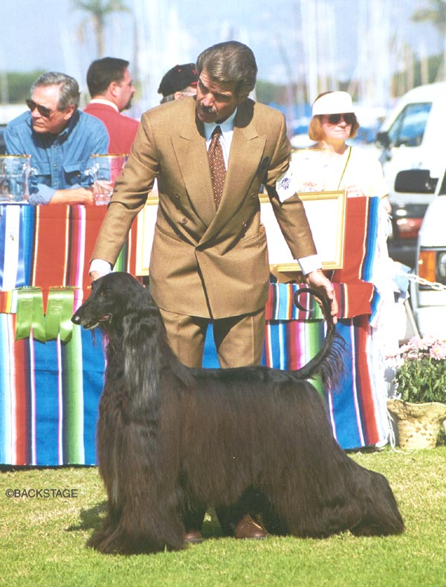
What age do we consider a dog an adult? I would say anywhere from 2 years to 3 years of age. This will vary due to the individual maturity difference, both mentally and physically. Some dogs are very slow to mature, and others are fast. Some dogs are born an old sole, while others are forever young. But what we are referring to mostly here is coat maturity. By the time your dog is 2 ½ years old or so, his coat should be much more manageable. Mating problems occurring less and less. The coat should be draping nicely. Hopefully your dog has the proper textured coat that is silky. The coat will just continue to grow and get longer and more beautiful. At this point your should know how to groom him correctly. Normally it is the drying time that increases, but not necessarily. Baring any major stress factors in his/her life; such as, serious infection, anesthesia, surgery, hormonal changes, such as whelping a litter or a false pregnancy, the adult will have an easy coat to maintain. If you should notice a change in the dog’s coat, such as excessive shedding due to any of the causes above, you will need to go back to the routine when he was an adolescent. Check the coat daily and make sure any illness gets treated promptly and properly.
At this point, he/she should be well behaved on the grooming table. He/she should also be well trained on a lead and to all show procedures. He should be settling down to be a much more obedient, loving and gentle companion.
When bitches come in season, they can start dropping coat as I talked about above in the adolescent stage. Some bitches drop more, others less and sometimes it goes by unnoticed. Infections and injuries treated with antibiotics or any type of cortisone medication can cause a coat drop.
SENIORS:
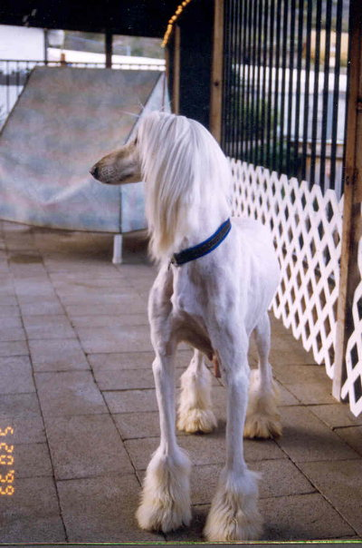
As your dog ages, he/she will become more stressful for him/her to spend hours being groomed, you may feel it is in your dogs best interest to clip back some parts of the coat to reduce the grooming time for him. You will also probably notice that his/her rear usually starts to weaken first and the dog may have problems standing on the grooming table for long periods of time. He/she may be very unsure of him/herself in slippery tubs. At this point, you will have to decide if it is worth the dog being in full coat for your ego. Truthfully, he/she could care less about his beautiful full coat. I, myself, think they look great clipped down if put in a really cute clip.
WEEKLY MAINTENANCE BATHING
- First put the dog on the table and go through the coat to see if there are any large mats or foreign objects caught in the dog’s coat (i.e., sticks and twigs, etc.) Remove them if you find any, but carefully so as not to break too much coat. Lightly and carefully brush out any mats that you find. Unwrap ears or cut out bands in the dog if you have wrapped ears or banded him and remove any dead hair accumulation around the wraps and comb out ears. It is not recommended to dry brush out a dirty coat, especially dried urine in the coat; this will cause undo breakage. Once the coat is shampooed and cream rinsed the coat will be easier to brush and comb though and mats will be much easier to remove with less coat lose. Take the dog to the tub.

- Standing up in the tub method: Start with rinsing the coat with lukewarm water completely saturating the coat. This can take some time to get the water thoroughly through a thick long coat.
- Or: Lying down method If I am using a conventional tub, I like to train the dog to lie down in the tub. Fill the tub with water up to about 1/3 of the dogs rear hocks while he is standing. Pour the Summerwinds Shine-Onnn Shampoo or Summerwinds Remove-A-Way Clarifying Shampoo or Summerwinds Fine-L-Shine Cream Rinse or Summerwinds Protect-A-Coat Oil Conditioner (whichever one you are using) pour full strength (about the same amount of product as you would dilute each product in water according to the bottle direction) into the tub water. With your hand mix the product into the water. Now have the dog lie down. While soaking the dog in the tub water and product mixture, scoop the water mixture over and over the dog. This is a way to save a lot of time. The dog will probably fight you the first couple of times you try and getting them to lay down in the tub water. That is why it is a good idea to start them out laying down in tub when they are puppies.

- Teaching the dog to lie down in the tub. Kneel down in front of the tub facing the side of dog that is standing in the tub of water mixture.. Hold the dog’s shoulder with your right hand and gently push his shoulder away from you (this will cause him to be off balance.) At the same time you have a hold of the dogs rear hock (the farthest one from you), gently pulling him/her towards you, will cause the dog to loose his standing balance and the dog will lie down. Now, he will probably try and jump back up fast, so quickly hold down the shoulders and hindquarters and tell him to stay. Assure him/her that he/she is okay. Like I said, it may take a couple of times before they get the idea of what you want and that he/she is not going to go completely under the water and drown. You may become as wet as the dog during this training period. This method does save a lot of time because instantly the dog’s coat is completely wet, plus you have to apply the shampoo or condition to the coat at the same time.

- Standing method: If the coat has any buildup from styling products or other brand products used prior, use Summerwinds Remove-A-Way Clarifying Shampoo as directed. Followed by applying Summerwinds Shine-Onnn 6.5 pH balanced Shampoo (diluted as instructed) to remove dirt and any oil or product buildup from the coat, lather working in by squeezing the coat in a downward motion (being careful not to tangle the coat) completely over the dogs entire body. Or, if using the Lying down method: follow the direction above, add Summerwinds Remove-A-Way Clarifying Shampoo and Summerwinds Shine-Onnn Shampoo full strength into the water and have him/her lie down into the shampoo and water mixture scooping it over and over him/her. Let soak for a minimum of three (3) minutes. Make sure that the coat is super clean before you condition. Rinse out Summerwinds Shine-Onnn Shampoo with lukewarm water. If you have a shower pick attachment, it is easy to rinse the dog with clear water. Rinse out all of the shampoo completely. Water is good for the skin and helps it to re-hydrate.

- Next, apply Summerwinds Fine-L-Shine Cream Rinse (diluted). Apply to entire dog. Or if using the Lying down method, following the directions above, then pour full strength Summerwinds Fine-L-Shine Cream Rinse into the tub. Lie the dog down in the tub, scoop the water and Summerwinds Fine-L-Shine Cream Rinse over and over the dog. Allow dog to soak for a minimum of three (3) minutes. You may choose to leave Summerwinds Fine-L-Shine Cream Rinse in the coat and you can either not rinse out. Or rinse out Summerwinds Fine-L-Shine Cream Rinse completely according to the dogs type of coat and condition. Whatever works best on each individual dog. You will know by trying it both ways and decide for yourself. I like the result on some of my dogs when I leave the product in the coat (for a deep conditioning treatment). Some of my other dogs, I like the way the coat combs outs better when the Summerwinds Fine-L-Shine Cream Rinse is completely rinsed out. This is mostly determined by the texture and the amount of coat the dog has. I find detangling thick, fine coats easier when all products are removed. Dry, damaged, coarser coats work well when product is left in the coat. You will have to figure out which is the best method for each of your individual dogs.

- Finally apply Summerwinds Protect-A-Coat Oil Conditioner (diluted), Summerwinds Protect-A-Coat Oil Conditioner is an oil conditioner that we use to condition and protect the coat and restore elasticity to damaged coats. Summerwinds Protect-A-Coat Oil Conditioner is also used as a preventative treatment to preserve and protect coats that are in good condition. Summerwinds Protect-A-Coat Oil Conditioner is recommended for conditioning treatments and maintenance grooming. We do not recommend you use Summerwinds Protect-A-Coat Oil Conditioner for show grooming because it can leave the coat oily. Dilution: I cannot tell you the exact dilution parts per water due to so many variables, coat types, different texture factors and how and where the dog lives, and what kind of condition that the dog’s coat is in. You will have to use your own judgment and experiment until you find just the right amount of dilution for each of your own dogs. This could be anywhere from 1 Tablespoon to as much as a 1 Cup or more of Summerwinds Protect-A-Coat Oil Conditioner to 5 gallons or more of water. I wish I could be more precise, but it’s impossible without seeing the dog in person to get just the right dilution for each different (not to mention breeds) dog. Some people will use Summerwinds Protect-A-Coat Oil Conditioner full strength on some areas, such as the ears tips (when wrapping) and loin area of a male to prevent urine staining, and anywhere you want extra protection. Standing method, pour the diluted mixture over all the dogs long coat, or if Laying down method follow the above directions and scoop the diluted Summerwinds Protect-A-Coat Oil Conditioner over head, ears, and neck, shoulder, front and back legs, side coat, brisket and tail completely saturating. I do not recommend that you apply Summerwinds Protect-A-Coat Oil Conditioner mixture over the saddle coat (short coat of their back and top line) on dark coated dogs. Some dogs will get a little dander in their saddle. Oils will cause old skin cells to slough off, making way for new fresh cells, which is a good thing for the skin, but you don’t want to see dry flakes in the dog’s saddle.

- Hot Towel Treatment: For a really deep conditioning treatment, whenever you can, wrap your dog in towels and let it sit 10 to 15 minutes with Summerwinds Protect-A-Coat Oil Conditioner. You can even warm the towels in the tumble dryer first to get the full warming impact! This is a good time to clean your dog’s ears, cut toenails and clean teeth while you are waiting. As we described in the Summerwinds Protect-A-Coat Oil Conditioner information sheet on how to use Summerwinds Protect-A-Coat Oil Conditioner, you can now rinse out all of the Summerwinds Protect-A-Coat Oil Condition with warm water. The towel will cause the coat to clump and stick together a little so when deep conditioning treatment with towel, rinse extra well with lukewarm water. When you rinse out the Summerwinds Protect-A-Coat Oil Conditioner with warm water, the conditioning agents in the product will rinse out leaving the refined flower oils remaining in the coat and protecting the coat until shampooed out. Or leave Summerwinds Protect-A-Coat Oil Conditioner in the coat and do not rinse it out for another way to deeper condition. In this method the warming towels are not necessary because Summerwinds Protect-A-Coat Oil Conditioner will remain in the coat until the next bath. Then again, you must decide which is best for each dog’s coat. I put Summerwinds Fine-L-Shine Cream Rinse and Summerwinds Protect-A-Coat Oil Conditioner in together and dilute them together, to save time by only doing one procedure instead of two. This is up to you. I then let the dog soak in the product for a minimum of three (5) minutes and everything else is the same as above procedure.

Grooming Table Time:
- Now it’s time after you have bathed the dog to take him/her to the grooming table. Once you’ve hooked him to the grooming arm, squeeze out as much water as possible. then towel dry him/her to remove as much excess water as possible. Be careful not to tangle the hair with the towel, rubbing in a circular motion. Always try squeezing the hair in the towel in a downward motion. Again, there are many different opinions on how to groom. Some people like to groom the dog out totally when he/she is still damp. That is my preference. Others, would rather start blow drying and brushing the dog dry. If this is your preference, mist the coat first with thermal protection. I will admit that if you have tight mats in the dog’s coat, the heat from the dryer will help loosen the hair some (De-matting link). Blow-drying the dog with heat can be very drying and will damage coat if you continually blow-dry with heat. Blow dryers are the one thing that can damage coats the worst. The heat damages the elasticity and opens the cuticle layer. An open cuticle is more sumpject to breakage. For maintenance grooming, I prefer to brush and then comb thoroughly through the coat until I am sure I haven’t missed any mats. If it’s a warm day, let the dog air-dry. If it’s a cool day, put a towel in the bottom of a crate and crate dry him/her. I have walk in dryers, but crate drying works almost as well. After he/she is totally dry, put him/her back on the table and run the brush through him/her again finishing with a thorough combing making sure you don’t miss any mats. Wrap or band ears or any other areas you wish, and you are done until his next bath.
- Note: Ear Wrapping: (link- to Wrapping and Banding Coats) I highly recommend wrapping or banding ears if you want those long beautiful ears. Plus, you won’t have to snood (a tube like scarf with elastic at both ends that is slipped over head and neck to protect ears) the dog while feeding to prevent the ears from food getting into the ears and being eaten off. If you are going to be wrapping the dog’s ears and other areas such as topknot, loin, side coat, etc., you can apply Summerwinds Protect-A-Coat Oil Conditioner and/or Summerwinds Fine-L-Shine Cream Rinse Paste full strength to those areas while the dog is still in the tub and the hair is wet or on dry hair. Why I say Summerwinds Protect-A-Coat Oil Conditioner and/or Summerwinds Fine-L-Shine Cream Rinse Paste is because both work equally well and in conjunction with one another. This protects the ears and helps reduce so much mating around the wraps. Again, you must decide for yourself which product works best for your dog. Snoods are good for show days to keep the ends of the ears clean and out of the mouth. If you use the snood for long periods of time, it can cause some ear problems from the warmth and no air circulation. On very delicate thin topknots, the elastic in the snood can cause some breakage. Snoods are good for short periods of time only. Plus, most dogs learn very fast how to remove the snood from their head.

DE-MATTING:
When you are dealing with long coated dogs with or without undercoats, it doesn’t take very much neglect to find that you and your dog are in big trouble. if you miss three or four weeks of proper grooming with an Afghan going through coat change, you may have to shave your dog.

Mats are ugly and will ruin a show coat if not controlled; not to mention very uncomfortable for your dog. Mats will pinch and pull the skin and if they get bad enough, the dog him/herself will begin to chew and try to de-mat his/her own coat.

Most mats are created from external influences. The most common is lack of GROOMING on a regular basis or by a well meaning, but inexperienced groomer. Fleas, ticks and mange or lice. irritated itchy skin will make the dog scratch. Fleas are one of the worst if the dog is allergic to Flea saliva. The dog’s saliva and chewing will set a mat to where it is almost impossible to untangle. Ticks are usually found on the ears or head and in between their toes. If you see a puffed-up female Tick that is engorged in your dog, look for its male mate. Ticks can cause serious diseases such as Encephalitis and Rocky Mountain Fever and should be dealt with immediately. First, kill the tick by applying alcohol or nail polish remover on a cotton swab. Grasp the Tick with tweezers as close to the skin as possible and gently twist and pull, causing the tick to release. There is no cause for alarm if the head remains fixed, rarely will it become infected. As it can cause an irritant to the dog that he may chew or scratch at causing not only mats, but skin rashes.

Different types of coats will mat differently. Soft and silky longhaired breeds such as Afghans, Maltese and Shi Tzu can mat in clumps and spots that will have to be removed. Double-coated dogs (i.e., the Alaskan Malamute, Great Pyrenees, etc.,) go through natural shedding processes according to their environment. It is essential that the shedding under coat be removed so the skin can breathe.

For the de-matting process you will need patience, time and the right equipment. Summerwinds Stat-A-Way Antistatic & DeTangle Spray and Summerwinds Fine-L-Shine Paste used straight from the jar and (diluted) in a sprayer are great detangling aids

If the dog is lightly mated, mist the coat first with Summerwinds Stat-A-Way Antistatic & DeTangle Spray; then carefully brush and comb out some of the mats in a dry coat. If the dog is very mated and you are willing to spend hours de-matting while blowing dry the coat, carefully brush or comb out as much as possible before bathing the dog. Once the mats are wet, it can becomes much more difficult to untangle them, but it will save coat. The heat from the dryer will help to loosen the mat.
You will need a good steel comb (I use a Greyhound comb or the Untangle rotating tooth comb), a pin brush and a slicker brush, which is a brush with fine steel needle like pins. If you can take a regular pin brush and brush out any loose hair going with the grain of growth, you may not have a tough job ahead at all.
Get the dog to lie down and become comfortable. One thing that is a must is to start at one end and work down the leg or body in sections. Do not move to the next section until the first one is completely de-matted. If you skip around all over the dog, you will get lost and miss many areas. If you spend your whole time fighting the dog to stay still, it becomes very exhausting for both of you. If you can control the dog’s head, you have control of the dog and that is imperative. Be sure not to pull so hard that it is painful for the dog, as most will not be co-operative for further de-matting. If you tightly hold the tangle between the skin and the knot before combing the mat out, it will prevent most pulling pain and discomfort for the dog.
Take the mat between your fingers and try to separate it with a gentle pulling downward and sideways. Dividing the mat into small sections will help to save a lot of hair loss. Separating it by hand is impossible so try using a slicker brush first. Brushing over and over in a downward motion is careful not to twist your wrist; this will cause coat breakage. Start at the ends of the hair and work your way into the skin.
Mats make noise.
Listen to the mat. You can hear a mat. When you are brushing with either a pin or slicker brush, mats make noise. You will learn to listen for the sound of the brush moving through the hair. When the brush hits a tangle or a mat it makes a different sound. When the coat is mat free, the brush or comb will glide through silently. I tell my owners, I cannot only smell a mat, but I can hear it. After the brush gets most of the tangles out, it is best to take the comb and remove any fine hair that still may be knotted. Make sure that the entire mat is removed by taking a long-tooth steel comb through the hair. If it does not get caught up on a tangle, you have a de-matted dog.
Remember, the more patience you have, the calmer the dog will be and the faster the job will be completed. Good luck.

DE-MATTING AIDS:
Summerwinds Fine-L-Shine Cream Rinse Paste and Summerwinds Stat-A-Way Antistatic & Detangle Spray are really good aids to help relax a mat and untangle them. If you take a scoop of the Summerwinds Fine-L-Shine Cream Rinse Paste in your fingers and message it, full strength, and work the product into the mat, wait for a few minutes and begin pulling gently downward and sideways, and the mat will begin to loosen. Gently brush through the mat with a pin brush. Finish by holding the mat next to the skin with one hand using your fingers, and with the other hand gently run the long toothcomb through the mat. Start at the bottom of the mat working up to the skin until the mat is totally untangled. Where the dog is lightly mated, spray on Summerwinds Stat-A-Way and message into mated area. The Summerwinds Stat-A-Way will help loosen mats both on bathing and grooming days and days in between.
A new product to our line… The Untangler Pet Grooming Combs have special rotating teeth that remove tangles easily, without the pain of pulling and snagging. Conventional rigid-toothcombs pull at your dog's coat and tear out hair by the root. The Untangler combs take away the pain and the tangles in one easy motion. I have found these combs to be very helpful in dealing with mats and is great for coats that are changing and/or going through coat drop. They work great with breeds that have undercoat (thick, very fine fur type coat under their longer top coat). I liked them so much that Summerwinds is now distributing them. They come in several different sizes, for cats to large dogs.
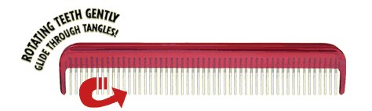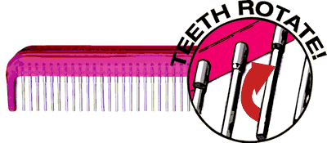
Showsheen spray, primarily for horses, can be found in feed stores and tack shops. This is another product that can be helpful in loosening mats during coat changes and when de-matting is a daily routine. Never dry brush a dry coat; always mist with water or Summerwinds Stat-A-Way Antistatic & DeTangle Spray first.
GROOMING TOOLS:
The grooming tools that you will need and use the most is:
- A Pin Brush: A large paddle type pin brush, which should have long pins that have a rubber bottom. Do not use pin brushes with balls on the ends of the pins. They will pull out too much coat.
- A Long-Tooth Comb: The most popular long-tooth comb is a stainless steel comb called the Greyhound The long-tooth comb used primarily on long-haired cats. Another great comb is the Untangler comb with rotating teeth.
- A Slicker Brush: The slicker brush is a short-handle brush with a flat base and very fine metal bent teeth. Great for puppy coats and detangling a mat if used correctly. It should always be used very carefully in a downward direction and never in a twisting motion. It is great to use on a very heavy coat. I have known many really good groomers that use nothing but a slicker. But they know how to use it. What is good for one person may not be preferred by another person, due to not knowing how to use the tool correctly.
- Stand Blow Dryer: Grooming Table with Grooming Arm: Nail Clippers: Hair Clippers: Scissors (thinning and regular), and Tooth Brush:

SHOW GROOM:
- The show groom is done very much the same as the above maintenance bathing. If you are not using Summerwinds Remove-A-Way Clarifying Shampoo, you may want to use a second Summerwinds Shine-Onnn Shampoo if the dog is extremely dirty, or if you have added a heavy dilution of Summerwinds Protect-A-Coat Oil Conditioner and you think he is extra oily. The first shampooing removes most of the dirt or oil, but leave the dogs natural oil in the dog’s coat. An Afghan, unlike some of the sporting breeds, doesn’t have that many sebaceous glands and natural oil dander. That is why people who are allergic to dog’s dander, but tolerate being around the Afghan, Poodle and other drier coated dogs. I recommend the less shampoo if you can help it for better results. On the show groom, you will not apply the Summerwinds Protect-A-Coat Oil Conditioner.
- You will apply Summerwinds Fine-L-Shine Cream Rinse diluted. Follow the directions on the bottle or whatever works best for your individual dog. Rinsing out Summerwinds Fine-L-Shine Cream Rinse will vary due to several factors, such as the type and amount of coat the dog has, and the weather conditions that may cause static electricity in the air (i.e., a dry Santa Anna), or hot to dry and cold weather. If you want to control the coat from fly away static, you may want to leave some or a lot of Summerwinds Fine-L-Shine Cream Rinse in the coat. If the dog has a bushy, cottony coat, leaving some Summerwinds Fine-L-Shine Cream Rinse in the coat might help it hang down and drape better. In fact, with bushy, cottony coats, I will add a small amount of Summerwinds Protect-A-Coat Oil Conditioner to the shampoo this will sometimes help the coat to drape as well. If the dog’s coat is thin and silky you may want to thoroughly rinse out all of the Summerwinds Fine-L-Shine Cream Rinse, or it might leave a little oily appearance. You will have to figure out what is best for each individual dog. Do some test grooms on non-show grooms until you find what works best. Wring out the dog’s coat as much as you can to remove excess water in the tub; squeezing in a downward motion.
- Take the dog to the grooming table and towel dry him to remove as much moisture from his coat as you can. Do not rub the coat too much in a circular motion with the towel, and be careful not to cause mating. Squeezing the towel in a downward motion over and over to remove water. Put a couple of towels in the bottom of a crate and put the dog in the crate for about 15 to 20 minutes. The towels can help to remove a lot of the moisture and leave the coat damp.
- After the 20 minutes is up, put the dog back on the table. If you are using the standing method, hook his collar to the grooming arm. If you are using the lying down method, lay him/her on his/her off-show side so that you can start to dry his show-side first. Now start the drying process. The desired show coat for the Afghan is straight, draping downward coat. Curly or wavy coat is not desired. If the dog is standing, aim the blow dryer at the top of the dog’s side and working downward (water will run from the top of the dog to the feet) With the dryer nozzle pointed at the dog’s coat, start brushing the coat with a pin brush directly under the dryer nozzle; brushing in a downward strokes while applying some presser to pull out any wave in the coat. The brush should glide easily through the coat. Once that section of coat is dry, move down the leg or body. Then start the next section in the same manner until the entire dog is thoroughly dry.
- Make sure that the finished dog is completely dry to the skin with no damp spots on the elbows, behind ears or the underbelly. Dampness will cause the coat to mat faster. Any dampness will also cause the wave or curl to come back into the coat. Now that the dog is thoroughly dry run the comb through the entire body making sure that the dog is mat free. Go through the finished dog with a steel comb with long teeth and a cool airflow on your dryer. The cool air helps close the cuticles layer and relaxes the hair from the harsh heat from the blow dryer that helps to straighten and dry the dog’s coat. Finishing with a cool dryer after the dog is totally dry also sets the hair and helps prevent the wave or curl in the coat to return.
He/she is now ready for the show ring. Your job is now to keep him clean until the show(s) are over. This is where different methods are used. A snood for the ears. Banding of hair or hair clips to prevent the males from urinating on their side coats. Legging’s for males that will urinate on the back of their legs. Our Pee Vest, Snoods, Legging and Boots are big sellers that help to keep the dogs clean. 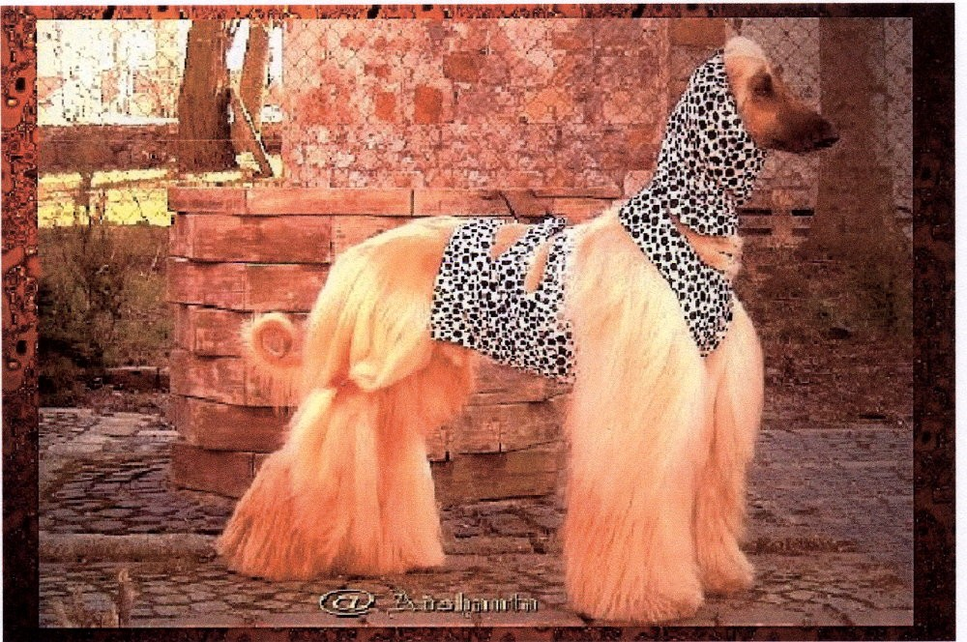

WRAPPING AND BANDING COATS:
EAR WRAPPING:
Ear and body wrapping and hair banding is a good way to protect the coat and prevent hair breakage. There are many different ways and materials used to wrap coats. Some of the materials used in wrapping are plastic, silk, or with parchment paper. I use parchment paper that are pre-folded, deli papers that are used to wrap deli sandwiches and sumpmarine sandwiches. These work the best for me. I purchase them at Costco. Brand name -James River- Food Wrap product parchment - made in MI 49004, 500 sheets, 12” X 10 3/4”. There are two different methods I use to wrap ears. Both start out in the same way. As I said, these papers come in boxes pre-folded in half like Kleenex. I then fold the already pre-folded sheet in half again. Next, I open the fold I just made back to the beginning to the way they come in the package, which is in half pre-folded size. I use the fold line I just made and fold the edge to that fold and fold again to the end. Sort of like in a roll, instead you have creased and folded into fourths, until you end up with a narrow folded paper. The reason for folding the paper is it’s much easier to work with and to fold the hair inside of.
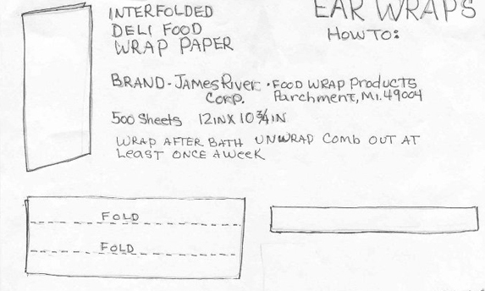

One is to wrap the end of the ears coat in packages
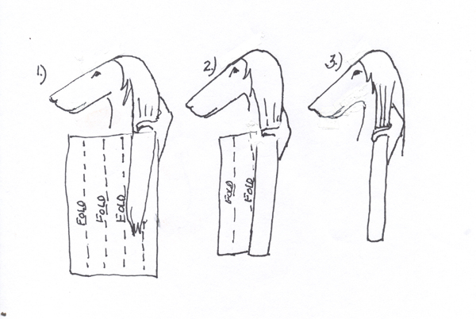
  - I am right handed, so I start by holding the dog’s ear in my right hand and slide the paper underneath the ear. Make sure to slide the paper to below the ear leather. Do not fold the ear leather in the paper.
  - Bring one fourth of the paper in front of the ear and hold the ear coat in tightly with your right thumb.
  - Then with your left hand, fold the last fourth of the paper around to the front of the dog’s ear. Still holding on to the dog’s ear and wrap in your right hand.

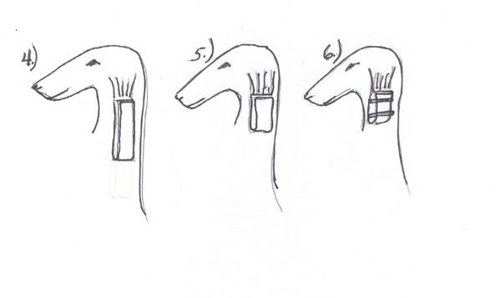
  - Fold the ear wrap in half with your left hand, still holding onto the dog’s ear and the top of the wrap in your right hand.
  - Fold the wrap in half again with your left hand, still holding onto the dog’s ear and the top of the wrap in your right hand.
  - You hold onto the wrap package with your left hand so it will be easier to wrap the rubber bands around the ear wrap with your right hand. Caution: You will first want to check and make sure you have not caught the dog’s ear leather in the paper wrap by taking a long toothed steel comb and run the teeth between the end of the ear leather and the top of the ear wrap. Now it is time the rubber band the wrap to the ear. I use two, you will want to wrap them enough times around the wrap so that the ear package in snugly secure.

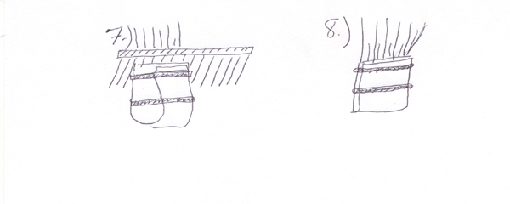
  - Insurance: Check again with the steel come to make sure the teeth can go completely through between the tip end of the ear and the wrap package. If you should catch the end of the ear leather and rubber band it tightly into the wrap, it can cut off the circulation and you could loosen the end of the dog’s ear. This is very important to not forget to do everything as you wrap the dog’s ears.
  - The dog’s ears are wrapped in packages. The other wrap I use the most is the same wrapping as fig.1.2.3. 4. 5. Wrap the end of the ear fringes in the paper and wrap up to fig 5. 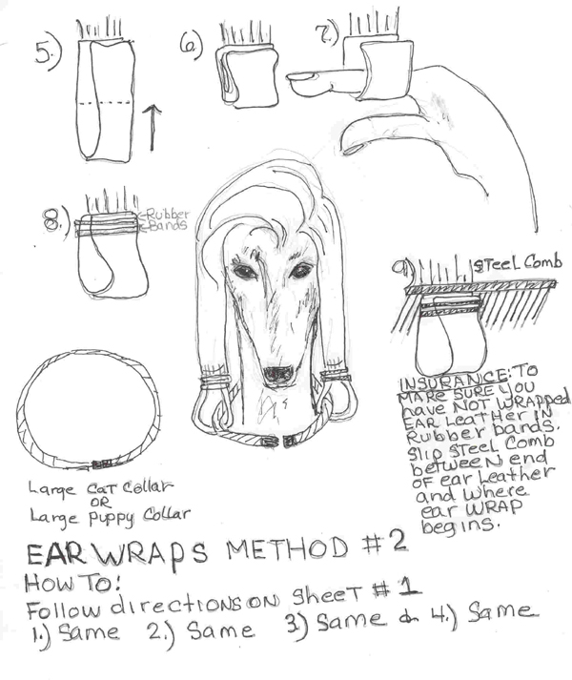
- Fold up wrap in half.
- Fold up wrap in half again.
- Open wrap and insert your finger so that the wrap has an open area.
- Wrap rubber band around the top of the wrap. Insert a steel comb between the end of the ear leather and the top of the wrap to make sure that the rubber band has not wrapped the end of the ear leather. Be sure to see the teeth of the comb from the opposite side.
- Now, run a small collar around the neck and through the ear wraps to hold the ears close to the neck, which is a safe way to make sure that the wraps don’t get caught on anything or that the dog or his kennel mates don’t chew off the ear wraps and eat off the ear coat along with the wraps.

- Removing the Ear Wraps: The length of time you leave the ears wrapped will vary a little. I usually leave them up until their next bath. Some people like to check them more often, that will be up to you. When you unwrap the wrap there will be hair wrapped around the part of the ear where the wrap was; it might even be some what mated. What has happened is the loose hair that the dog normal sheds will gather around the top of the ear wrap. Gently pull it apart and then brush with a pin brush and comb through the ear with a steel comb and it should remove easily. Some people are of the belief that you can loose too much ear coat by wrapping ears. I don’t find that to be true. I feel that you can loose more ear coat by one accidental eating the ear fringe off. 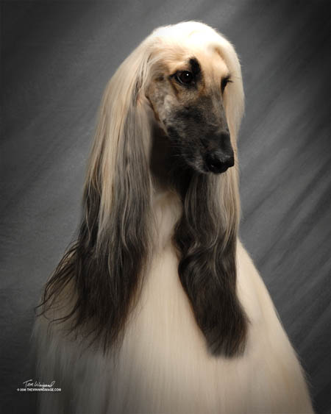

BANDING:
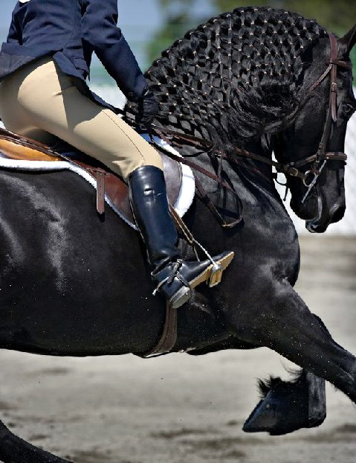
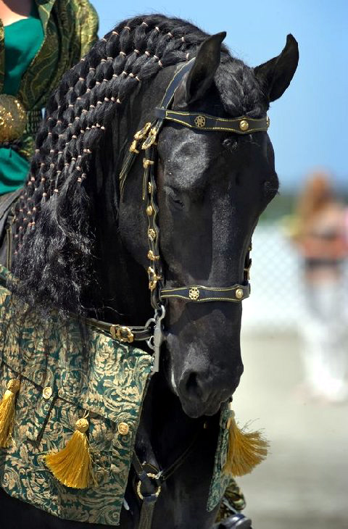

Banding up the coat of the adult Afghan Hound is an another way to protect side coats on the males for protection of the groin hair area from urine stains. Banding also protects ear coat from getting into the dog’s mouth. Some people will use this method as a weekly routine. Others will only band in between shows to keep the dog clean. It is a great way to keep a full-coated male who is in the house all the time from getting urine on their side and leg coat to prevent the dog from smelling like urine.

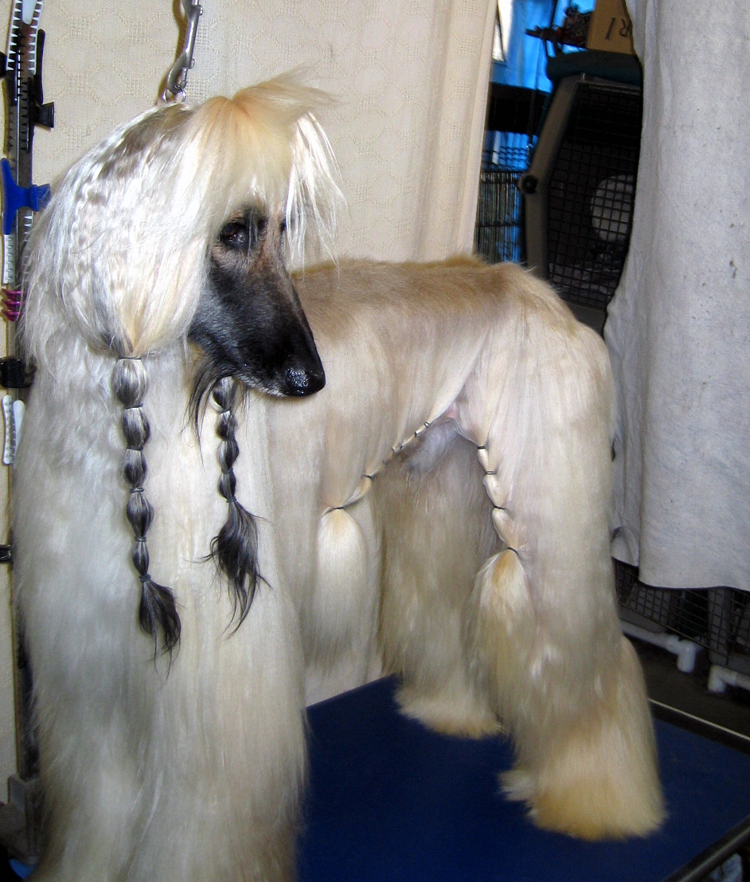
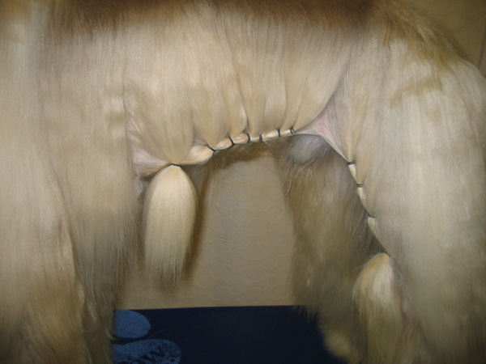

People will use different types of rubber bands. I prefer the small bands that the toy breeds use in their topknots, made of latex material. They don’t break hair. To remove, just cut the band out of the hair. Some people will use the rubber bands that are used in children’s hair and covered with nylon. To band the hair, start from the groin and wrap the side coat forward and the leg coat downwards. Take about a 2” piece of hair and wrap a rubber band around it, making a very small ponytail. Then take another 2” piece of hair next to the first one and connect together with a rubber band to the first ponytail, like a French braid. Continue doing the same along the dogs underline until you have tied up the coat to where it is up and out of the way and won’t get soiled.
- Then for the rear legs, start again at the loin area. With a 2” piece of hair, wrap it in a pony tail, then take another 2” piece of hair, band to the first ponytail and wrap the two together working down the stifle front part of the rear leg until you have tied up all the leg coat you think will get dirty. Be careful not to band too tight at the base
- This method can be used also on a bitch down their rear legs to tie up their skirts from being soiled by urine. Start at the top of the bitches rear and top of the back leg. Make the first 2” ponytail then connect the next 2” piece of hair along with the first ponytail; rubber band both together. Then take the next 2” piece of hair and rubber band it to the first two. Continue the same way down the back leg until you reach the hock. Be careful not to band too tight at the base.

SHAMPOOING AND CONDITIONING MADE EASY
RECYCLING TUB METHOD:
I have two recycling tubs that I use. One is used for shampooing and the other for cream rinsing and conditioning. A recycling tub is a walk-in tub that has a reservoir below the floor that you fill with water and add product (i.e., shampoo or conditioner). It has a motor (much like a sump-pump) that pumps the water out of the reservoir filled with the mixing of water and product through a sprayer hose onto the dog. Once you are finished shampooing/conditioning the dog, you unplug the reservoir and drain out the product & water mixture. With another sprayer rinse the dog with clear water. I really like my tubs because they save time and product. We use to sell these tubs, but they are quite expensive, and to my knowledge no longer available.

SUMP-PUMP RECYCLING METHOD:
Here’s all you will need: A Sump-Pump, Short Garden Hose, Shower Sprayer, Electric Power-Surge Strip, Old Pair of Panty Hose, Shower-WaterPik* (brand name) Sprayer Attachment. Use it for an inexpensive, efficient, and effective time and product saving method to bath a dog.
You can get the same effect as my recycling tubs by using a sump-pump from your local hardware store. The smallest one they make will work great! Take an old panty hose or knee high nylon stocking and pull over the bottom of the sump-pump (this will keep hair from being sucked up into the sump-pump causing it to clog or over heat) The sump-pump has a hose connection on the bottom of the unit. Purchase a very short length of hose (10 to 15 feet) and attach to the sump-pump. On the end of the hose, attach a shower sprayer. Nothing elaborate, just a cheap plastic shower sprayer works great. You’ll need an electric power-surge strip to plug into an electric outlet.

Now plug your sump-pump into the electric power-surge strip. This has a on and off button. (You can also purchase a foot switch that you can step on that turns the pump on and off, but they can be expensive and the power-surge strip works fine.) Fill the bottom of your bathtub with water up to about 1/3 of the dogs hock, add Summerwinds Shine-Onnn Shampoo or Summerwinds Remove-A-Way Clarifying Shampoo or Summerwinds Fine-L-Shine or Summerwinds Protect-A-Coat Conditioner (whichever one you are using) full strength into the water until the desired mixer of diluted product is achieved. Emerge the sump-pump into the bathtub of water and product mixer. Holding on to the hose and shower sprayer, turn on the sump-pump (keep a dry towel close to dry your hands off before turning on or off the sump-pump via a power surge protector.) The sump-pump will start to pull the water mixture up through the hose and out the shower sprayer. Then hose down the dog’s entire body, spraying in a downward motion. When spraying the head, protect the eyes. Once the dog is thoroughly shampooed, turn off the sump-pump, unplug the tub and drain out the shampoo mixture.

Next, with a separate Shower WaterPik (* brand name) sprayer attachment, rinse off the dog with clear, lukewarm water until all the shampoo is totally rinsed out of the dog’s coat. Now re-plug the bathtub and add the water again up to about 1/3 of the dog’s hock, filling tub with Summerwinds Fine-L-Shine Cream Rinse, or a mixture of both Summerwinds Final-L-Shine Cream Rinse and Summerwinds Protect-A-Coat Conditioner. Rinse completely using clear water. This is a very fast and thorough method. It applies the product and wets down the dog in one easy application plus being a great product saver. Next, towel-dry the dog that’s ready for grooming.

TABOO HINTS: AFGHAN TRIMMING…
I know this is a very touchy subject. Like walking on holy ground. A kind of hypocritical oath of show grooming an Afghan. Something most people do, but don’t admit to anyway to the power’s to be. Because the Afghan hound standard states, the Afghan Hound shall be shown in its natural state. The natural state of an Afghan Hound is mated. Show me what’s natural about a dog show and I will concede. Some old time breeders would say you may remove hair if you pull or pluck it out between your figures by hand, and that’s okay. That is like being a little bit pregnant. Either you do trim or you don’t. Show me a top- winning competitor that is showing Afghans today that says they don’t trim, and I will show you one that is showing a highly patterned dog or a liar.
For the novice, that is at a big disadvantage to begin with, competing against the old time pros it’s very hard for them to present their dogs in a competitive groom when there are no manuals, guidelines, or books to refer to which address the taboo subject of trimming the Afghan Hound. Some breeders, owners and handlers will share with the newcomer that is if they know the true art of trimming themselves.
Here is my attempt to help with this subject of trimming the Afghan Hound. Here are some of the tools used to trim an Afghan Hound so the dog will appear as natural as possible.

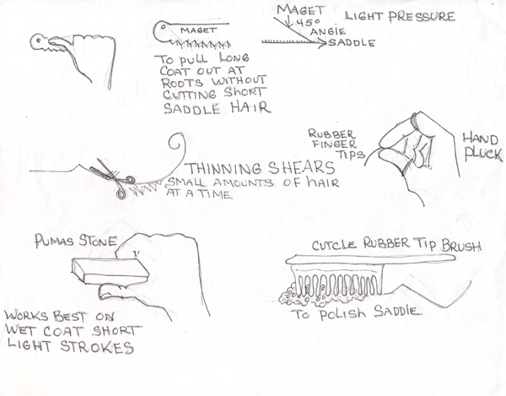
- Magnet Trimmer, is a tool, if used properly, removes fuzz in the saddle coat, without cutting the undercoat short hair.
- Thinning shears for stubborn hair at the base of the tail, cheeks, muzzle, and other areas.
- Rubber figger tips to hand pluck out coat.
- Pumas Stone to remove fuzz in saddle, cheeks, and muzzle. I prefer the Magnet Trimmer because the Pumas Stone will cut the under hair saddle. The Pumas Stone is easier to learn to use.
- Cuticle Rubber tipped brush to use in saddle while bathing to polish and remove any dander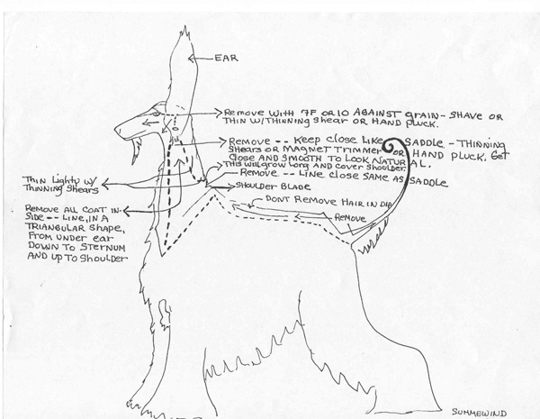

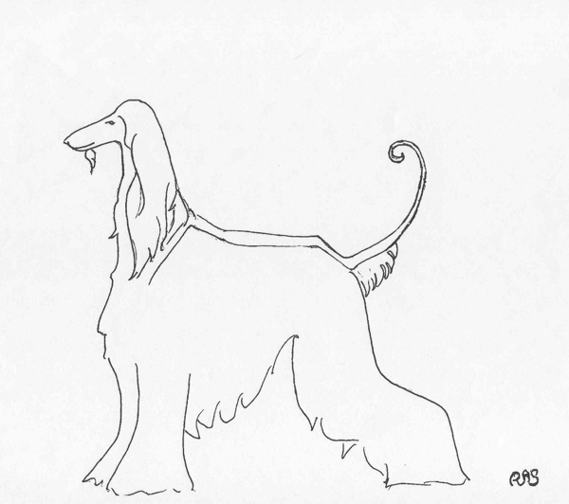

EXERCISE:
This is not a sumpject that should ever be over looked. We are asking these dogs to be stars, excel and be a cut above. No different than an Olympic athlete, they need the proper diet, rest and exercise to be able to compete. Remember dogs sleep almost 80% of their lives away. For the show ring, they don’t really need a lot of endurance like they would in the wild. But the better shape they are in, the longer they will live, and the more effortless their movements will be. Exercising the dog should be done on a regular daily basis. They should free run in an enclosed area. Long walks and jogging either next to you or along side you, or running with you on a bike will benefit both you and the dog.
Anatomy of the Afghan Hound
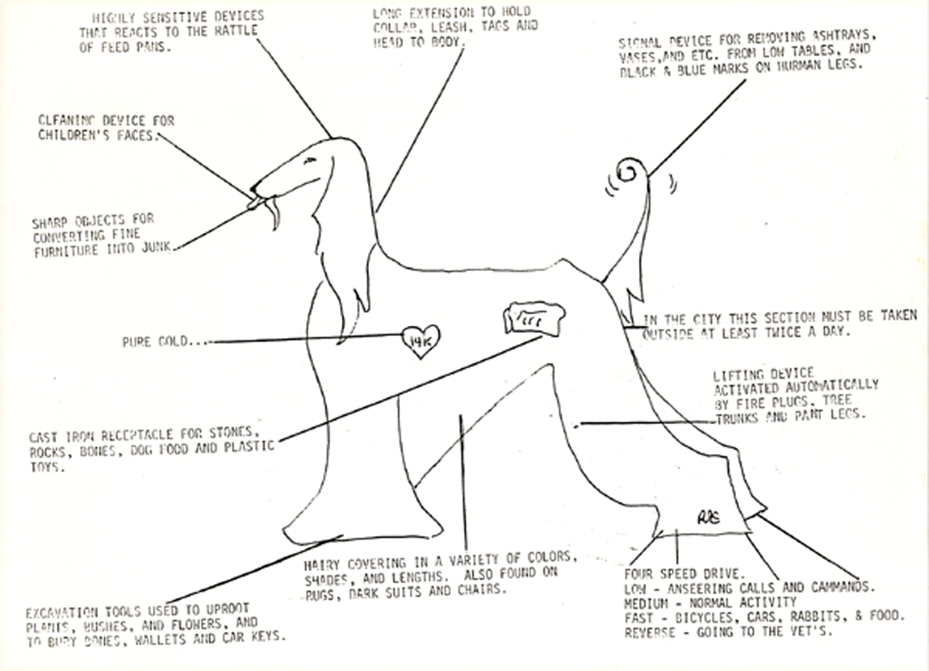

Head: Highly sensitive devices that reacts to the rattle off feeding pans.
Tongue: Cleaning device for children’s faces.
Teeth: Sharp objects for converting fine furniture into junk.
Heart: Pure Gold…
Stomach: Cast Iron receptacle for stones, rocks, bones, dog food and plastic toys.
Front Feet: Excavation tools used to uproot plants, bushes, and flower, and to bury bones, wallets and car keys.
Coat: Hairy covering in a variety of colors, shades and lengths. Also found on rugs, dark suits and chairs.
Legs: Four Speed Drive: Low: Answering calls and commands. Medium; Normal Activity. Fast: Bicycles, Cars, Rabbits, & Food. Reverse: Going to the Vet’s.
Rear Legs: Lifting Device Activated Automatically by Fire Plugs, Tree Trunks and Pant Legs.
Rear End: In the city this section must be taken outside at least twice a day.
Tail: Signal device for removing ashtrays, vases, etc. from low tables, also known as a lethal weapon, leaving black & blue marks on human legs.
Neck: Long extension to hold collar, leash, tags and head to body.
This is very old. Author: UNKNOWN. Whoever wrote this hit the nail on the head, and I felt it was worth sharing and passing on to a new generation.

Afghan Hound Rescue's
http://www.google.com/search?hl=en&ie=ISO-8859-1&q=Afghan+Hound+Rescue&btnG=Google+Search

This is just TWATR... The World According To Rosemary. If you have any suggestions or comments or additional hints I would like to hear them.
We welcome any helpful hints, techniques or articles you use that you would like to share.

Email Us Here
Forward to a Friend

