SKIN PROBLEMS AND DISORDERS:
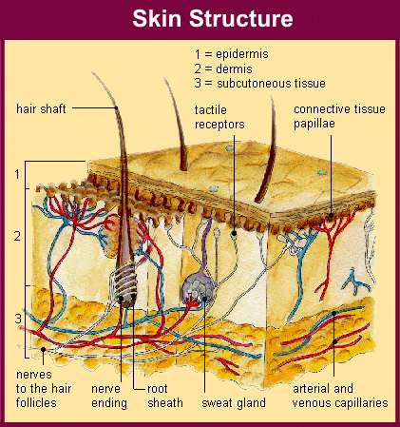
Whether you are trying to cultivate a show coat or just keep a pet in healthy condition, the internal system of the skin is the one of the most important tissue to maintain. It is the largest organ in the body. If your animal suffers from skin disorders not only will he be uncomfortable and sometimes even in pain, there is no way on earth you will be able to put a gorgeous show coat on your animal until you find the source and cure. So if your animals start to show signs of any skin problems, deal with it immediately! Do not procrastinate; these problems don’t usually cure themselves. Summerwinds has two products that can aid in the relief of itching. Summerwinds Stop-N-Itch Bath and Summerwinds Stop-N-Itch Lotion. Dry and itchy skin can come from many reasons, as I am sure you are aware of.
- Allergies from foods, or things in their environment
- Topical Products (i.e.) shampoo's conditions, styling agents, etc.
- Cold and dry weather or hot and humid change in seasons.
- Fleas or Ticks
- Stress can cause mites to activate causing Mange or Cytological Problems
- Disease or Yeast Infection
Below are a couple websites that will explain it more scientifically.
http://www.thepetcenter.com/gen/itch.html
http://www.k9web.com/dog-faqs/medical/canine-allergies.html

